**Final Project Paper: Zoom Edition**

**Janzen Molina (A16334662), Rajvir Logani (A16041655), Shihan Gong (A17129477), Sunay Bargotra (A17221160), Fiona Liu (A16880107), Johnathan Tinajero (A164545458)**

**Course: Design of Everyday Things (DSGN 1)**

**Studio Section: A01 (Wednesday 9:00-10:50 AM)**

**Section I: Data Collection**

**Brainstorming**

Our group started brainstorming by first making a **mind map** of all of our ideas (Figure 1). The **mind map** was split into two sections: digital and physical. Considering we had a lot of time for this project, we leaned towards doing something digital and landed on two options: Zoom and Pronto. From here, we made a list of possible problems to explore within the two apps (Figure 2).

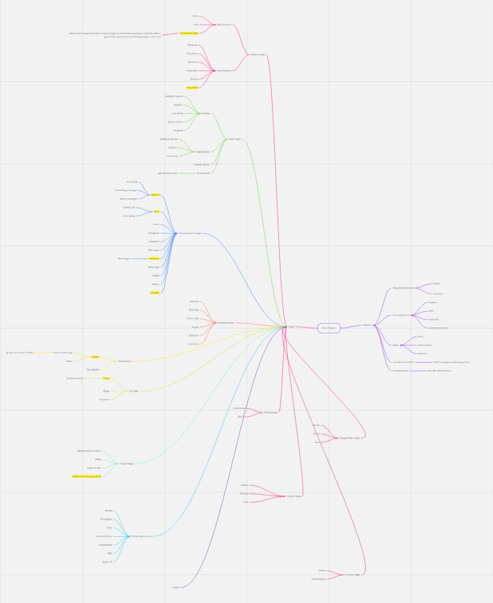

*Figure 1:* [*Mind map*](https://miro.com/app/board/uXjVOMK45uU=/?invite_link_id=6013144576) *of different digital and physical designs.*

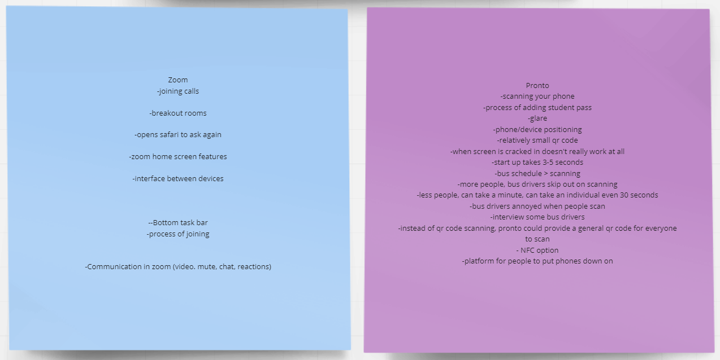

*Figure 2: Different aspects of Pronto and Zoom that we could focus on*

We eventually decided on Zoom and its various communication features: video, microphone, chat, and reactions. However, after a few interviews, we realized that covering all of these features may be too overwhelming for one project. We had a meeting and decided that we wanted to focus on the chat, as our data had shown that there were multiple problems in that specific area. These included problems with messaging the wrong person or having trouble distinguishing between the breakout room and main chat.

**Methodology**

For our final group project, we had to do two interviews in order to create our redesign, and to do this, we collaborated with each other to create our interview questions and procedures for the task. We first shared a Google Doc for all of our team members to draft their basic ideas, such as brainstorming and interview questions. After, we set up our first meeting in which we all looked at those ideas and discussed them with each other in order to create the first interview. Due to the current pandemic situation, we decided to conduct our interviews both in-person as well as online through Zoom, which was perfect for us since our topic is about how people use Zoom; with this, we could see how familiar the interviewees are with using some of the Zoom functions, such as the camera, the microphone, the reaction functions and the chat function. Our interview questions were divided into three categories: general questions, task-based questions, and post-task questions. During the in-person interview, we shared a Zoom link with the interviewees and either sat next to them or video chatted them on another device. While asking interviewees questions, we also did a talk-along process to help the interviewee elaborate on their process better; instead of letting the interviewee fill out the Google Form, the interviewer filled it out while observing the interviewees’ behavior during those assigned questions. For some of the online interviews, the interviewee and the interviewer both had to join the same Zoom meeting, and then the interviewee was asked to share their screen; this was actually an advantage, since it allowed us to clearly observe how our participants interact with Zoom. We each conducted our 3-4 interviews independently and then immediately typed their responses and our observations on a Google form for a cohesive collection of data.

After all of us finished our interviews, we set up the second meeting to discuss the results in order to get prepared for the next section. However, during the second meeting, we noticed that our topic of Zoom communication functions was a little bit too broad, which meant if we continued with the data we collected from the first interview, it would cause our project to lose focus. Based on the first interview data, we found out most of our interviewees have frustrations with the chat function, and therefore, we decided to do a follow-up interview that only focused on the chat function. We created more specific questions about the chat function and did our secondary interview with the exact same people and the same procedure from the first interview. We ended up being able to collect more precise data and even some unexpected data that helped us move to the next step more easily.

Our interviewees were mostly students from UCSD, but also included people that were our siblings, friends, parents, and roommates that were from different age ranges since we wanted to ensure our data is not biased. However, due to the ongoing pandemic, it has been hard for us to reach people from different fields and networks. Our data is a little bit skewed since most of our participants are students that are under 23 years old. The other factor that we have to take into account is that people under this age are more familiar with technology and students are more familiar with using Zoom, especially during this unique situation. Ultimately, though, this is pretty representative of Zoom’s target audience of students, teachers, and workers, as its primary function is video telephony communication for school or work.

We used the **master-apprentice model** to create our interview questions, as this model allows us to become the students and the participants can play the role of the teacher in order to demonstrate their knowledge to us. This way, later, it will help us see any misunderstandings we might not have caught in our designer perspective and make our redesign better. We adapted both open-ended and closed questions throughout the three types of questions (general, task-based, and post-task questions), as we thought this would allow us to build a solid foundation for collecting qualitative and quantitative data. We also embed a Liker-scale question into the task-based question section in order to see the difficulty level of using those functions. The following are our interview questions in two interviews:

[**Interview #1**](https://forms.gle/mDJ8BU9HV2Vxs3sV6)

Note: those questions in the parentheses are actually separate questions, we didn’t ask a few questions in one question, but I put it this way here because they belong to the same range.

General questions:

1. Name, age range
   1. This question helps us organize the demographics of our interviewees. Collecting the range of age will give us specific insights into different age groups. Also, having the name of each participant will help us to track who did each interview easier.
2. Are you familiar with Zoom? (How long have you been using it? How often do you use Zoom? How long do you use Zoom every time)
   1. Previous knowledge can impact their performance on the user task, so we asked this question to get an idea of our participant’s experience with the platform. By interviewing users with a wide range of experiences, we were able to get a wider range of problems. While there was some overlap, problems that new users have are very different than problems that more experienced users encounter.
3. What device do you primarily use Zoom on? ( What device do you prefer more and why?)
   1. Different people prefer to use Zoom on different devices; by asking this question, we can narrow down the scope in order to decide which interface of Zoom chat design to focus on as well as collect more data about what errors users usually tend to make when using different devices. Later, this will help us redesign the interface on one device.
4. What are some reasons/purposes that you use Zoom? (work, school, meet with friends, etc.)
   1. There is always a reason that drives the user to use that application. Asking this question will definitely help us to collect more qualitative data of learning the user’s needs so that we can redesign better to fit their demand and improve the user experience.
5. If you meet with friends, why do you prefer to use Zoom over apps like Skype, Facetime, Whatsapp messenger, etc.? OR, why do you prefer these apps over Zoom?
   1. There are lots of similar platforms or applications out there in the world. By asking this question we can not only learn more about other competitors, but also refine the current platform better for what field it should focus more on. Learning and comparing will help us to move smoothly into the next step for analysis and redesign, and eventually improve our own product.
6. What are the main features that stand out to you about Zoom? (which do you use the most often and can you name them all?)
   1. Asking about the specific features that Zoom has can reveal which feature is the most popular one and also help us dive deeper into details. Details determine success or failure, and this is the most important question for product improvement.

Tasks

General Task

* Please join the Zoom meeting from the link that I’ve sent.
* What let you know that you successfully connected to the Zoom meeting?

This task was carefully crafted in order to mimic common actions users may undertake in opening Zoom meetings. If the user were able to open the Zoom meeting correctly in a short amount of time, the designer’s **conceptual model** for designing the interface of the opening is clear and won’t cause a new user’s defeat in the future.

Mic Task

* #1
  + Please mute your mic
  + How did you know how to complete this task?
  + On a scale of 1-5, rate how easy this task was for you (difficult -> easy)
* #2
  + Please unmute your mic
  + How did you know how to complete this task?
  + On a scale of 1-5, rate how easy this task was for you (difficult -> easy)
  + What tells you the status of your microphone?
  + On a scale of 1-5, rate how clear the status of your microphone is. (difficult -> easy)

Video Task

* #1
  + Please turn your camera off
  + How did you know how to complete this task?
  + On a scale of 1-5, rate how easy this task was for you (difficult -> easy)
* #2
  + Please turn your camera on
  + How did you know how to complete this task?
  + On a scale of 1-5, rate how easy this task was for you (difficult -> easy)
  + What tells you the status of your microphone?
  + On a scale of 1-5, rate how clear the status of your webcam is. (difficult -> easy)Chat Task
* #1
  + Please send your name to the chat
  + How did you know how to complete this task?
  + On a scale of 1-5, rate how easy this task was for you (difficult -> easy)
* #2
  + Please send the word “hello” as a direct message to me in the chat
  + On a scale of 1-5, rate how easy this task was for you (difficult -> easy)
  + What tells you the status of your microphone?
  + On a scale of 1-5, rate how clear the function of the button is based on what you see before clicking the button. (difficult -> easy)
  + What tells you the sender of a chat message in each of these tasks?
  + What tells you who received a chat message in each of these tasks?

Reactions Task

* #1
  + Please send a thumbs-up emoji
  + How did you know how to complete this task?
  + What tells you that your reaction is showing?
  + On a scale of 1-5, rate how easy this task was for you (difficult -> easy)
* #2
  + Please send a heart-eyes emoji
  + How did you know how to complete this task?
  + What tells you that your reaction is showing?
  + On a scale of 1-5, rate how easy this task was for you (difficult -> easy)
  + On a scale of 1-5, rate how clear the function of the button is based on what you see before clicking the button.(difficult -> easy)

This task was designed to identify a potential design error within different functions and features on Zoom. The interviewer made sure to do a talk-along process while interacting with the interviewees. Not everyone is familiar with those functions, especially those who have never used one of those features, so including the open-ended and closed questions in the task-based questions, can help us to observe more **knowledge-based mistakes** as well as some **action-based slips.** For example, some people never use the reactions and some people never use the chat, or even situations where some people who know how to use the chat function, but didn’t notice that they accidentally sent the chat to the wrong person. In addition, these task-based questions also help us to see which feature causes the most frustrations.

Post-task questions

Video Post- Task

1. What are your current camera settings when joining a Zoom meeting? Did you set these? Do they vary?*
2. Are your camera settings constantly reliable throughout the meeting?*
3. How often do you turn your camera on, intentionally? Accidentally?*
4. What are some features you like about the video function? What are some features you’d like to change about the video function?

Microphone Post - Task

1. What are your current mic settings when joining a Zoom meeting? Did you set these? Do they vary?*
2. Are your mic settings constantly reliable throughout the meeting?*
3. How often do you unmute, intentionally? Accidentally?*
4. What are some features you like about the mic function? What are some features you’d like to change about the mic function?

Chat Post-Task

1. How often do you use the chat?
2. Who do you usually try to reach in the chat? (the entire class, the professor, etc.)
3. What are some features you like about the chat function? What are some features you’d like to change about the chat function?

Reactions Post-Task

1. How often do you use the reactions?
2. What are some reasons you use reactions?
3. How do you feel about the current quantity of reactions?
4. What are some features you like about the reactions function? What are some features you’d like to change about the reactions function?

Post task questions were originally created to help us establish a clear indication of what needs the most work done during the redesign process. This specific post-task accidentally helped us create interview number two, where we realized our main focus would be on fixing the chat. Trying to fix Zoom as a whole is very broad, but focusing on certain functions and the chat specifically helped us get into the detail of the problems we will fix. These post-task questions also helped us come up with new questions that will give us more details and data to work with when thinking of issues with the formatting and functionality of Zoom.

[**Interview #2**](https://forms.gle/JarkfWKFWhNktcrn7)

Updated chat questions:

* (NEW) Chat Task #1: Please open the chat
  + Did they perform the task correctly? Did they get it wrong? Did they change their mind? explain a little
  + How did you know how to complete this task?
  + Where does the chat open on your screen and how do you feel about its placement?
  + Do you have a preferred placement for the chat window?

This chat task question was added to our original interview because we wanted to see if **slips** would occur or if the chat function had a clear **signifier**. If an interviewee accidentally opened up another function while trying to open chat, we would find out there is an issue with **mapping** within the design.

* Chat Task #2: Please send your name in the chat
  + Did they perform the task correctly? Did they get it wrong? Did they change their mind? explain a little
  + How did you know how to complete this task?
  + On a scale of 1-5, rate how easy this task was for you
  + Why did you rate it this way?
* Chat Task #3: Please send the word “hello” as a direct message to me in the chat
  + Did they perform the task correctly? Did they get it wrong? Did they change their mind? explain a little
  + How did you know how to complete this task?
  + On a scale of 1-5, rate how easy this task was for you
  + Why did you rate it this way?
  + On a scale of 1-5, rate how clear the function of the button is based on what you see before clicking the button
  + Why did you rate it this way?
* At this point, send the interviewee a response to both their general chat and their direct message for reference in the questions below
  + What tells you the sender of a chat message in each of these tasks?
  + What tells you who received a chat message in each of these tasks?
* (NEW) Chat Task #4: Please send an attachment to the chat
  + Did they perform the task correctly? Did they get it wrong? Did they change their mind? explain a little
  + How did you know how to complete this task?
  + On a scale of 1-5, rate how easy this task was for you
  + Why did you rate it this

This chat task was added to see if users knew how the functioning of the chat works. There are several features on zoom that are unclear so we wanted to see if this was clear to the users. 18 out of 22 users knew how to send an attachment and they said they knew because of **knowledge in the head** rather than clear **signifiers.** We added the task to see if people knew how to do this function and if they did, how did they know.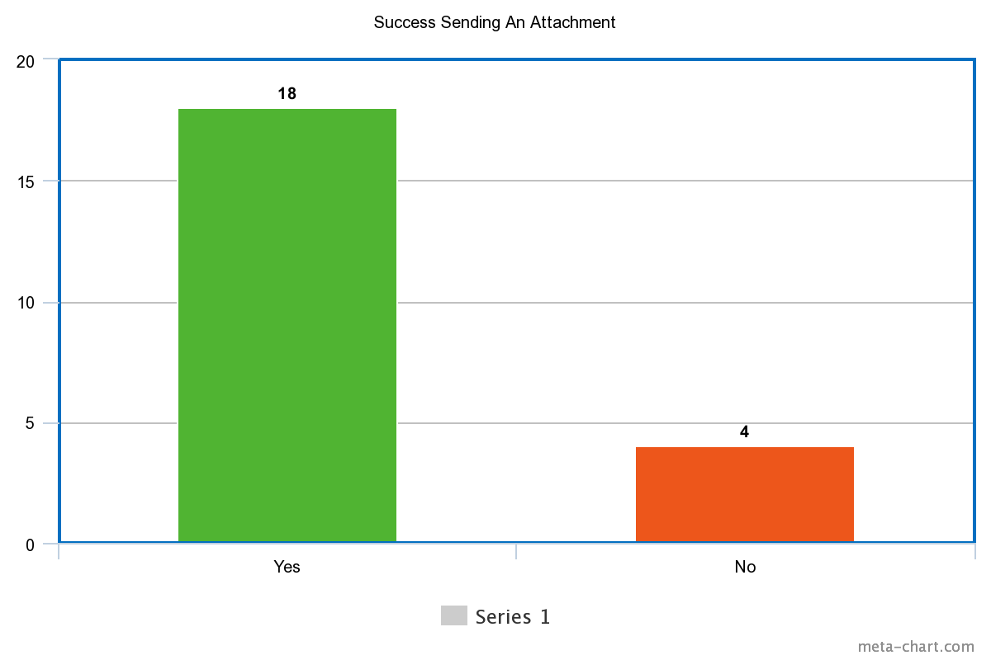

*Figure 3: Pi Chart demonstrating success in sending an attachment*

* (NEW) Chat Task #5: Please send an emoji to the chat
  + Did they perform the task correctly? Did they get it wrong? Did they change their mind? explain a little
  + How did you know how to complete this task?
  + On a scale of 1-5, rate how easy this task was for you
  + Why did you rate it this way?

This task was created to focus on a certain feature within the chat. We wanted to broaden our research about chat and learn about users' capabilities with other chat functions.

* (NEW) Chat Task #6: Please save a transcript of the chat and send it back to the chat.
  + Did they perform the task correctly? Did they get it wrong? Did they change their mind? explain a little
  + How did you know how to complete this task?
  + On a scale of 1-5, rate how easy this task was for you
  + Why did you rate it this way?

Once again this task was created to focus on a certain feature within the chat. We wanted to broaden our research about chat and learn about users' capabilities with other chat functions. This would help to see if **signifiers** for saving the transcript were clear.

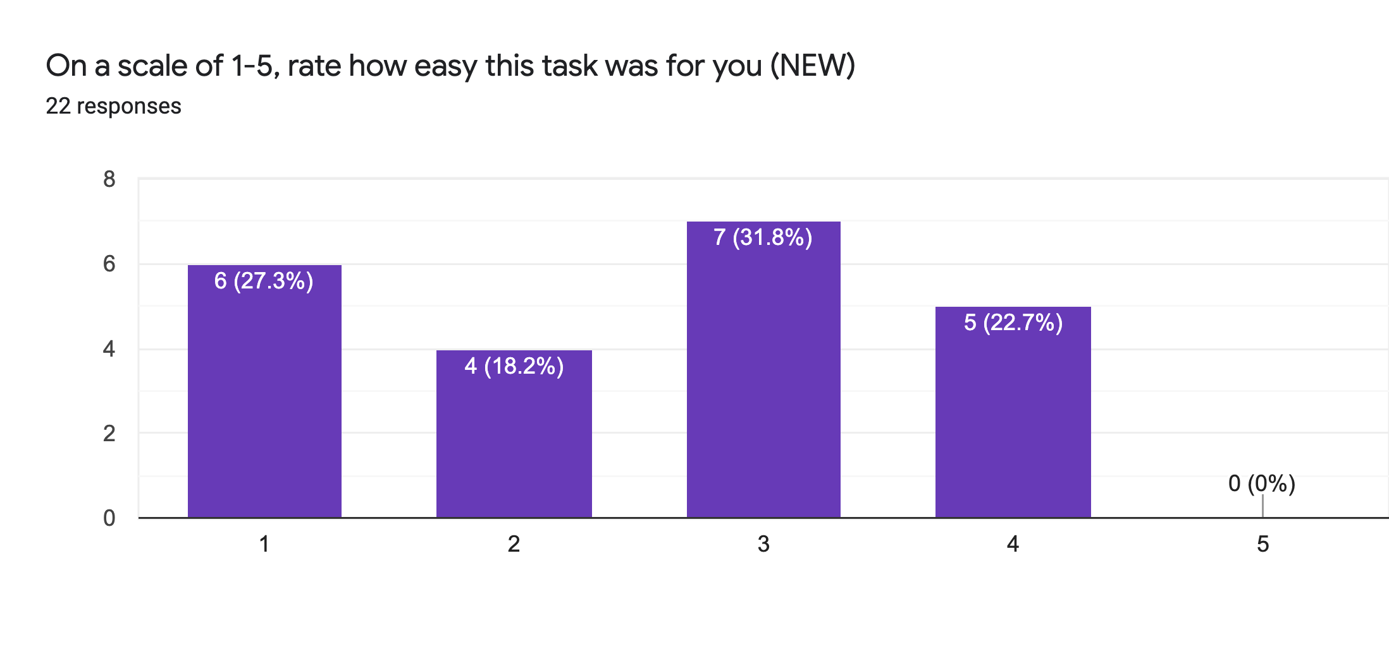*Figure 4: Success in Saving /Sending Transcript*

Chat Post-Task Questions

1. How often do you use the chat?
2. Who do you usually try to reach in the chat? (the entire class, the professor, etc.)
3. Do you have any experiences with the chat that stood out as good or bad?
4. What is your experience navigating the chat with various meeting sizes?
5. What is your experience having direct message conversations with various meeting sizes?
6. What is your experience navigating the chat with breakout rooms?
7. What are some features you like about the chat function? What are some features you’d like to change about the chat function?

This grouping of questions was the sole purpose of creating interview #2. We wanted to see users' experience with the chat functions. We wanted to make sure **signifiers** and **feedback** were as clear as possible for experienced and inexperienced users. Asking about a bad feature and receiving feedback could help improve the **gulf of execution** for our redesign. Learning about the users personal experiences can help us find **slips** and **mistakes** made during their process of using the functions which can help us with the redesign process.

**Proof of Data**

[Group draft interview questions](https://docs.google.com/document/u/0/d/1XVyHNlaM3Ch_P4R673wQ5aS7F3wxXeXZWS2khktq9n8/edit)

These are our start-up draft questions before we create the actual interview form.

Final project [interview #1 Google Form](https://docs.google.com/forms/d/1W5P9MV5qUTBcgzj8CJAh0VudrA9tQA9nnOpX_64_4DQ/edit)

Final project [interview #2 Google Form](https://docs.google.com/forms/d/1-YwPMA-ktqzwHWH73IkXdsQi3DkNP-l6VeeT1nPFysA/edit)

These are the fixed interview questions that we used for actual interviews after a few group meetings.

[Zoom user research response](https://docs.google.com/spreadsheets/d/1-P6zRMImYbeLLXHDc5Iy9mViqoBeSDhEjuM6D0eBHhE/edit?usp=sharing)

This is the Final Google Sheet that we collected from our interviews and used to do the following analysis.

**Contributions**

**Shihan:** Conducted4 interviews. Worked with Johnathan on the data collection part, split evenly on methodology and proof of data.

**Johnathan:** conducted4 interviews. Worked with Shihan on the data collection part and proofread methodology and inserted graphs for interview #2.

**Rajvir:** Conducted 4 interviews, provided some ideas and critique for redesign, did half of the problems and trends portion of the paper (specifically the “Errors and Issues with Direct/Group messages” section and the “Chat WIndow Positioning” section), and worked on original interview questions and made revised interview questions with Fiona.

**Janzen:** Led 3 interviews. Wrote half of the problems and trends section. Edited the team’s video content for the video and presentation parts of the project. Presented half of the analysis and conclusion for the slide deck presentation.

**Fiona:** Led 4 interviews; Formed interview questions as well as subsequent revisions with Rajvir; Worked with Sunay on redesign; Justification, Prototyping, Iterations, general editing and formatting

**Sunay:** Led 3 interviews on other fellow students. Worked with Fiona on ideas for redesign. Created graphs and definitions for the design space and worked on trade offs that our redesign has.

# **Section II: Problems & Trends**

**Unclear Signifiers**

Based on the data, we found that the participants were not able to identify some of the **affordances** the chat function offered as a result of the lack of clear **signifiers**. Specifically, the lack of a simple ability to find a particular person to send a direct message becomes frustrating for the participants. 7 out of 21 participants pointed out that scrolling through the list of people to message became an issue in larger meetings because of the longer time it took to find the person’s name in the dropdown list as the number of people in the Zoom meeting increased. This becomes an issue as the participants are consistently making a **knowledge-based mistake**. There is a much easier way to search for someone in the list of people, found directly above the dropdown menu in the form of a search bar.

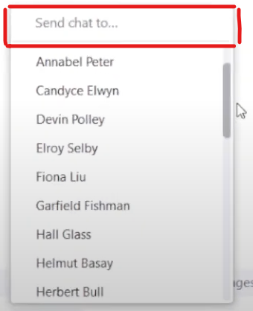

*Figure 5: The search bar above the list of participants in a dropdown menu for direct messaging. Note the lack of major distinctions between the bar and any participant’s name below it.*

However, there is a lack of knowledge from the participants surrounding this feature as demonstrated by the participants who continue to use the more difficult and time-consuming method of scrolling. In fact, participant #9 suggests to us that there should be a search bar in order to make the process more efficient, but the feature itself is already implemented! This lack of knowledge contributing to the participants’ inability to cross the **gulf of execution** is a result of the lack of easily accessible **signifiers** within the search bar. Currently, the bar is designed to be flush with the rest of the participant names in the dropdown menu, which makes the text blend in with the overall shape of the list. Furthermore, the text input area for the search bar is a slightly lighter shade of gray compared to the rest of the text, which, to a visually impaired individual, looks almost identical to the point where it would not be apparent to the user that the search bar exists. Lastly, unlike many websites and applications with a search bar function, the list does not give the **signifier** that it **affords** being searched through using an icon like a magnifying glass. In parts of the task where recognizing images was key to completing the task correctly, at least 8 of the 21 participants recognized a certain image that gave them hints regarding what function would occur when that particular button or area was interacted with. In the case of the search bar, however, no such icon exists. As a result, the people who rely on the images as a **semantic constraint** to deduce what would reasonably be done by clicking a button would end up getting confused and not completing the task in the most efficient way possible.

Another trend we noticed surrounding the unclear **signifiers** is the save transcripts button. A function exists in the Zoom chat that allows you to save a text file of all the recorded messages in the chat directly onto your computer. However, just by looking at the visual **signifiers** within the interface, you would not be able to guess that. This aligns with the data from our participants, where 11 out of the 22 participants interviewed had to guess where the button to save the transcript as a text file was located. The reason listed by all the participants was that the button itself is hidden by another button displayed as three dots on the interface.

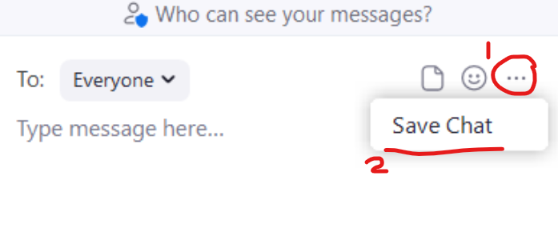

*Figure 6: A participant-eye view of the two-step process it takes in order to save a transcript of the chat.*

This makes what could be a one-step process into a more complicated two-step process, further proven by all 22 participants who did not give it a score of 5 signifying a clearly easy task on our scale (this will be further elaborated upon in a lower section). Additionally, because the function is hidden behind the three dots, the icon of the dots itself does not provide a **signifier** that is clear to tell the user that the chat **affords** being saved through the Zoom application. By means of **cultural constraints**, the interfaces designed in other applications have dots that users would recognize as a menu that would lead to several different options that could not be all listed on just one screen for visual cleanup and organizational purposes. However, the menu in the Zoom chat for participants only has one option- the save chat function- which defeats the purpose of using the three dots icon and goes against the **cultural constraint**, which further decreases the ability of the participants to cross the **gulf of execution** and understands how the saving feature works.

**Errors and Issues with Direct/Group messages**

One trend we noticed in our analysis of the interview data we had (for the second interview) was that a solid acknowledged the commonality of making errors in the chat by accidentally sending a message that was intended to be a direct message to the chat that included everyone and vice versa (sending a chat meant for everyone to someone in a direct message). Four out of 22 participants directly admitted to making this mistake themselves and another 3 acknowledged it’s an issue that they are cautious about and/or have noticed around them. So overall 7 out of 22 of our interviewees have recognized that this error is common. A couple of our interviewees mentioned that it often happened when they typed their message out and hit the enter key to send it without realizing what the chat’s recipient was set at. This can be acknowledged as a **mode-error slip** based on the fact that the chat user performed the right action but on the wrong setting/mode (the wrong recipient) and/or a **memory-lapse mistake** because the chat user forgot the current state of the environment (what the recipient was set as). Additionally, it could be considered a **description similarity slip** in the case that the user was not able to acknowledge the difference in the interface when sending a chat to everyone vs a direct message or vice versa. One of our interviewees provided a prime example of how prevalent this error is and how detrimental it can be by telling us how their “teacher once meant to send a student a direct message and the whole class found out [their] friend was failing” the class. This made it clear to us that the distinction between recipients in Zoom’s chat interface was not clear enough for people to notice and stop themselves from sending a message to the wrong person/people. This comes down to the two **signifiers** surrounding the direct messaging feature in Zoom. Firstly, the **signifier** that tells a user who the recipient of a message is (before it is actually sent, see figure #7) does not stand out, making it easy to ignore and nondifferentiable from other words (like “Type message here…” and “Who can see your messages?”) present in the interface. There are differences in that the recipient’s name (“Everyone” in figure #7) is black rather than grey and the recipient’s name is highlighted in grey but these are very subtle and based on the trend mentioned above, they don’t do a good enough job of allowing chat users to avoid errors by noticing who they are messaging before they send a message, and thus serve as poor **signifiers**.



*Figure 7: The recipient name in the Zoom chat interface*

Note its light color and similar font to every other word in the chat interface

The second **signifier** of a direct message is the red words that say “(Direct Message)” next to the recipient’s name (right above the text entry box) and next to the actual message that was sent (as can be seen in figure #8 down below).

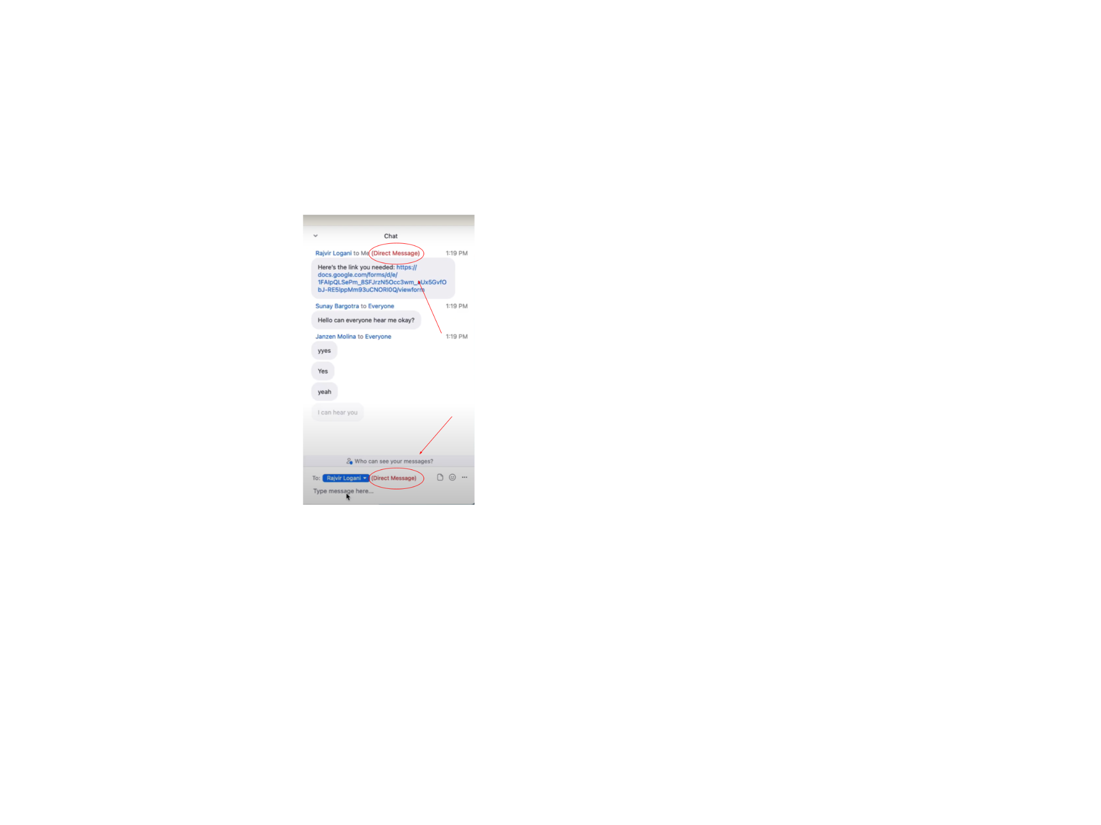

*Figure 8: The descriptive signifier of a direct message in the zoom chat interface*

Note the red lettering

This **signifier** is definitely more distinct than the first one due to the red coloring of “(Direct Message)” note which stands out from the rest of the colors. However, this was still not enough for some of our interviewees. One of the 7 interviewees mentioned above (interviewee #6), who was constantly cautious about sending messages to the wrong person, acknowledged the red lettering that tells one whether they’re sending a direct message or not, but noted that she wished there was a “ warning telling you more prominently who you’re sending a message too because it’s not absolutely clear.” These **signifiers** (the recipient name and the red lettering) are not clear enough for users like her. This same participant noted in her interview that when trying to reach out to an individual in the same Zoom meeting as her, she would go and direct message them on a different platform (like Slack) to avoid both sending a message to the wrong person and the potential of anyone else seeing the message. She would go out of her way to go to another platform to direct message someone because she was more comfortable with the way direct messaging worked on that platform than on Zoom.

Furthermore, 7 out of 22 of our participants (2 of them being participants who addressed sending messages to the wrong people as mentioned above) also noted that it was common for them to lose direct message chats within the stream of chats with everyone. Another 2 participants noted that it was difficult to manage direct messages within the main chat with everyone because the direct message moves up with every message sent to the chat with everyone, requiring one to scroll up to keep track of their direct messages. This made for 9 out of 22 of our interviewees that addressed frustration with direct messages integrated into the chat with everyone.

Additionally, 6 out of our 22 participants noted that they had experienced confusion navigating the chat within breakout rooms. 3 out of these 6 interviewees specifically stated that it was confusing to them whether messages sent to the breakout room would only be seen by others in the breakout room or by everyone in the meeting. One of these 3 interviewees stated why, explaining how even messages in breakout rooms say “to everyone” yet means everyone in the breakout room, not in the meeting. This “to everyone” note is a poor **signifier** as it says the same thing in the main room chat with everyone in it and thus leaves the meaning of the “everyone” recipient very ambiguous. Furthermore, one of the 6 interviewees who had experienced confusion with chats in breakout rooms stated that chats from the breakout rooms were “a bit confusing when you can see the rest of the meeting chat.” This is understandable considering that messages sent to the main chat with everyone and to a breakout room both have the headder “to Everyone” as can be seen in figure #9. Because messages from breakout rooms and the main room both have the same header and look the same, as can be seen in figure #9, the only way to truly distinguish between them is by memory of which messages were from the breakout room and which were not.

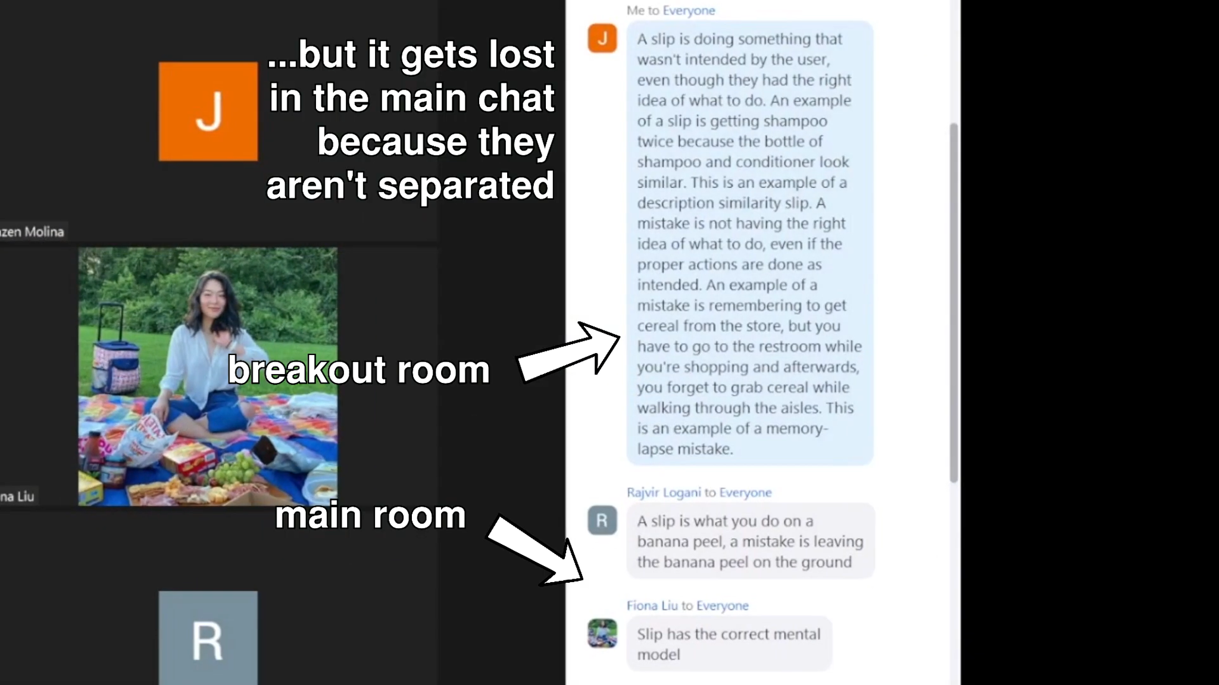

*Figure 9: The distinction between a breakout room message and a main room message.*

Note: The breakout room message is only blue because it was sent by “Me” all messages sent by “Me” are blue in any setting and all sent by others are grey, yet notice that the “to Everyone” tag in both messages are the same

The fact that there is no signifier to distinguish between these types of messages means that the developers of the Zoom chat completely replaced the use of **knowledge in the world** for **knowledge in the head** when it came to reintegrating breakout room chats into the main room chat. Additionally, the knowledge in the head required to distinguish between these messages would not even be considered **knowledge in the head** if a chat user was not paying attention to who sent the message in the breakout room or what the message said, to this user the two types of chats (ones from the breakout room and ones from the main room) would be indistinguishable. This point was evident in the fact that another one of the 6 interviewees who had experienced confusion with chats in breakout rooms firmly believed that all chats from breakout rooms disappeared when you leave said breakout room. While chats from the main room disappear when you go into a breakout room, as noted by another one of those 6 interviewees, chats from breakout rooms don’t disappear when you go back into the main room, they are just camouflaged amongst the other chats and thus not **discoverable**.

**Difficulty surrounding Task #6**

We found that all participants had some trouble when it came to completing task #6. In this task, the users were asked to save a transcript of the Zoom chat on their computer and send the attached text file back into the Zoom chat. On every other task, we found that at least 1 participant would rate the task as a 5, signifying it was an easy thing to do. For example, for task #5, where participants were asked to send an emoji in the chat, 20 out of 22 participants rated the task as a 5 on the same scale as the other given tasks. By contrast, 0 out of 22 participants rated task #6 as a 5, and 6 out of 22 participants rated the task as a 1, signifying the most difficult task imaginable.

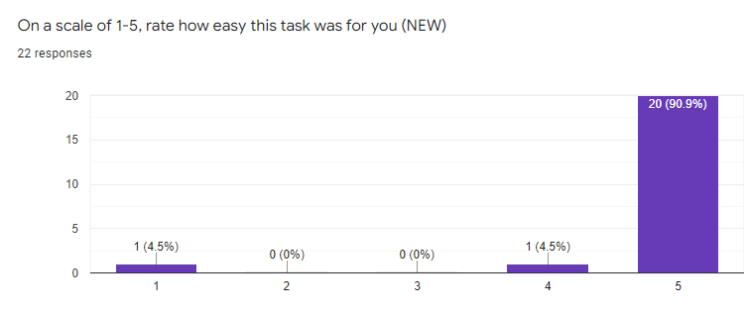

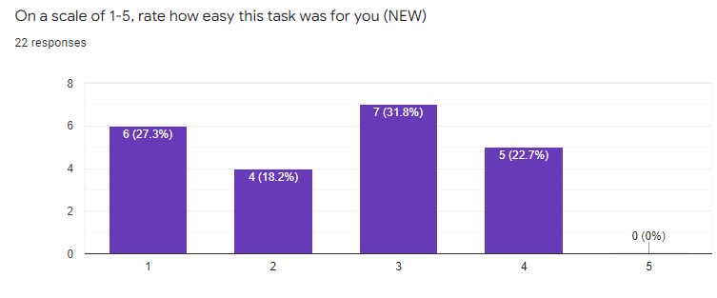

*Figures 10 and 11: Bar graphs demonstrating participant ratings for tasks #5 and #6 respectively. Note the extreme deviations between the rating distributions.*

The cause of this trend can be traced back to the lack of instructions given by Zoom once the user saves the text file to their computer. Upon saving the chat successfully, the program gives no clue as to how to complete the second half of the task, which involves searching for the text file within the participant’s computer so that they can send it back into the chat. People struggled with this because of their lack of understanding surrounding where the text file went after it was saved, leading to **knowledge-based mistakes**. This is further narrowed down by the data which demonstrated that 17 out of 22 participants completely and correctly sent any attachment into the Zoom chat while only 13 out of 22 participants correctly sent the text file back into the chat, and many of the participants that correctly did task #6 still took a lot of time to eventually figure it out. This exhibits the idea that the inability to find the file within the device’s storage is the root cause rather than a participant’s inability to send an attachment. There were also participants who specifically did the task incorrectly because they send the wrong file; this could suggest a **capture slip**. This is because those users may have sent other files several times throughout the day, which is common among the college student demographic that we studied closely. After working with computer files for much of the day, the participant might have sent a recently opened file that was more recurring in the user’s head rather than the desired text file.

**Chat Window Positioning**

Another trend we recognized in our interview data had to do with preference and feelings that interviewees had regarding the placement of their Zoom chat window. 11 out of our 22 interviewees stated that they preferred to have their chat windows docked to the right side of the Zoom window (shown in figure #12). On of these 11 interviewees elaborated stating that he was used to this chat orientation because it was standard across other platforms which he used regularly such as Twitch, thus the developers made good use of **cultural constancy** and **knowledge in the head** provided by the structure of other common platforms with this chat orientation. This however wasn’t the only orientation the chat showed up in when interviewees clicked the chat button. For 7 out of our 22 interviewees, the chat appeared in a small window separate from zoom in the center of their screen (shown in figure #13).

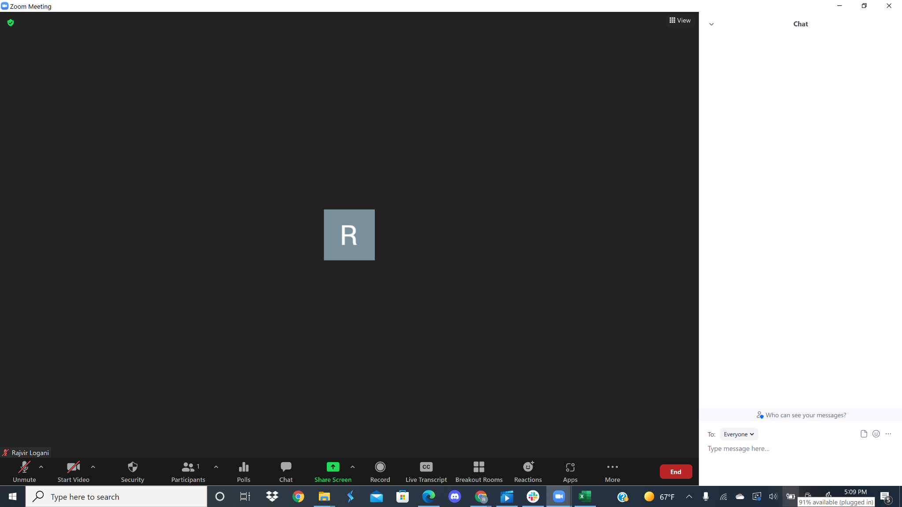

*Figure 12: The chat window docked to the right side of the Zoom window*

Note: (11/22 participants preferred this orientation)

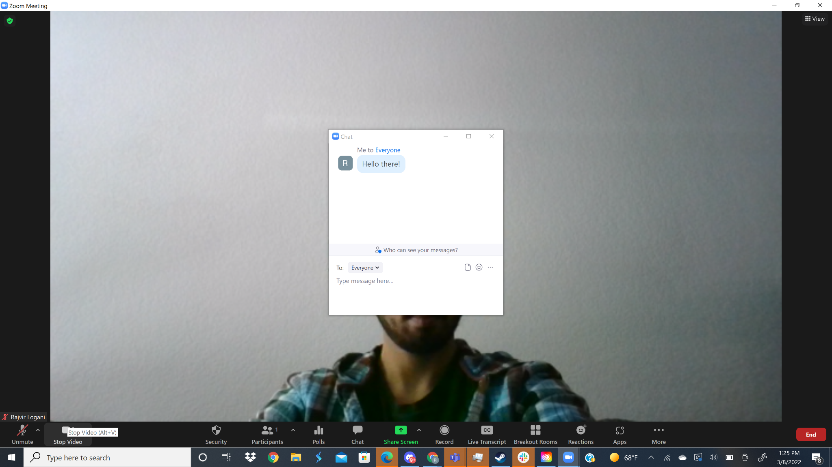

*Figure 13: The chat window appearing in the middle of the screen*

Note: it opened this way for 7 participants and only one stated they liked it this way

Interestingly enough we discovered that 6 out of our 22 interviewees actually preferred the chat in a window. 4 out of these 6 interviewees, however, preferred the window to be placed within a corner of the main Zoom window (shown in figures #14 & 15) so it was still there but smaller and out of the way. One of these 4 even stated that they don't like the chat window docked on the right side because it “takes up space” and that having the chat window “floating somewhere on the corner of the screen” was a good alternative that took up less space.

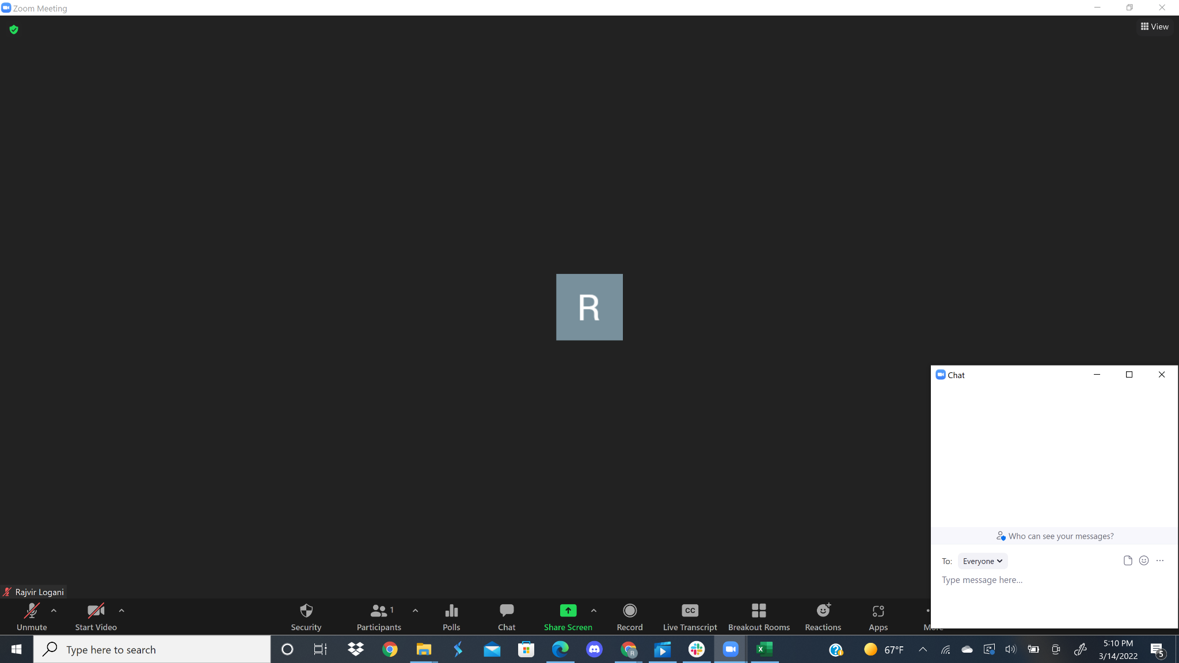

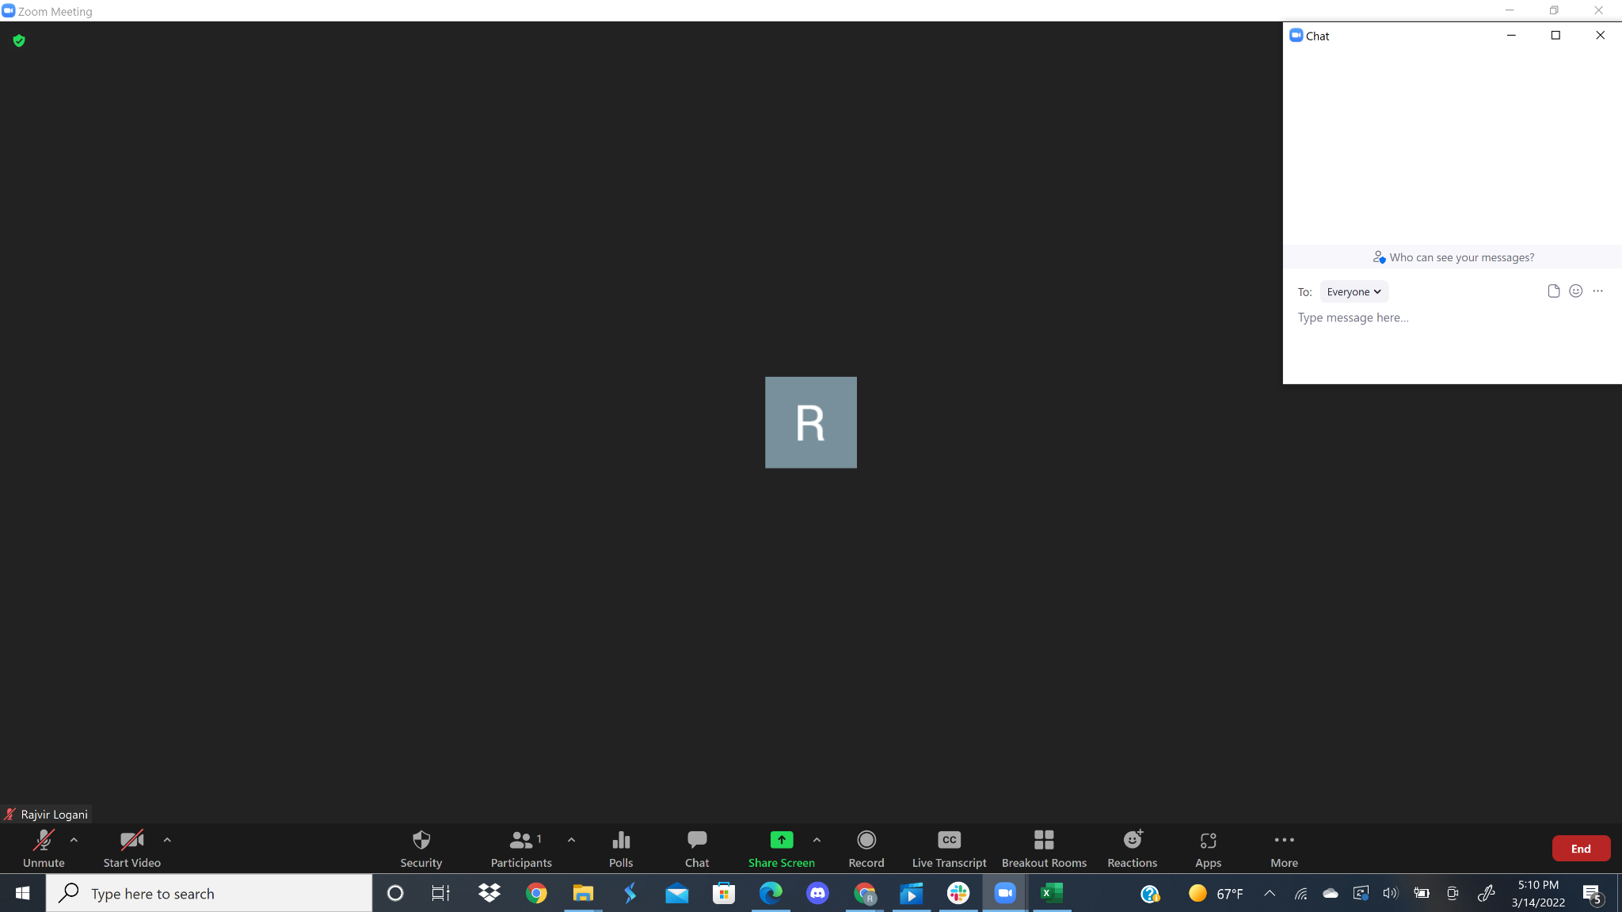

*Figures 14 & 15: The chat window in a corner on the side of the screen.*

Note: 4 of our interviewees stated they preferred the chat window like this

Only one out of our 22 interviewees actually liked the pop-up window showing up in the middle of the screen (shown in figure #13)but noted they would only have it open when they needed to use it and closed it right after while most other interviewees mentioned leaving their chat windows open for longer to the side somewhere. This data showed us that, overall, the most preferred chat orientation was one that was off to the side, but with that being said, making sure that the chat took up a small amount of space and was out of the way was important to our interviewees.

**Section III: Design Space and Redesign**

**Competitors**

**Zoom Google Meet**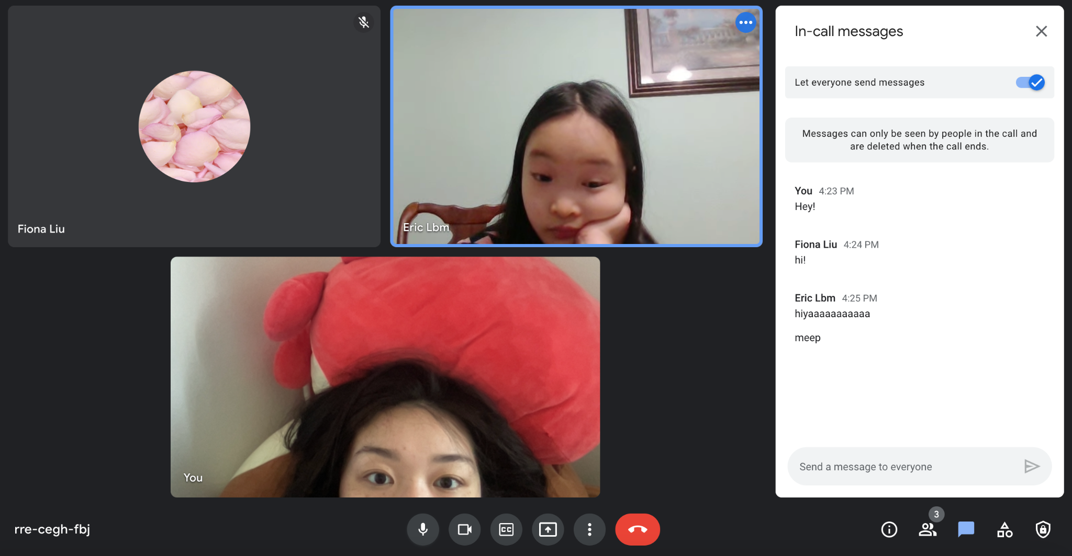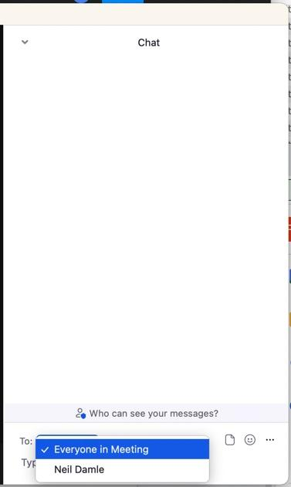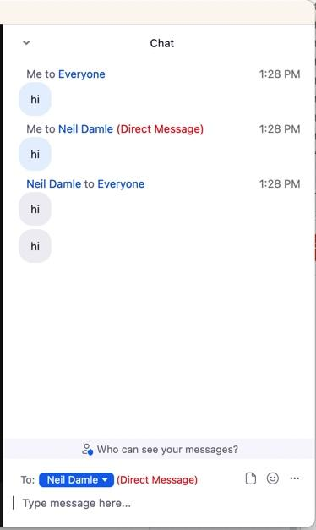

*Figure 16: Zoom’s Chat Interface Figure 17:*

*Google Meet’s Chat Interface*

**Skype**

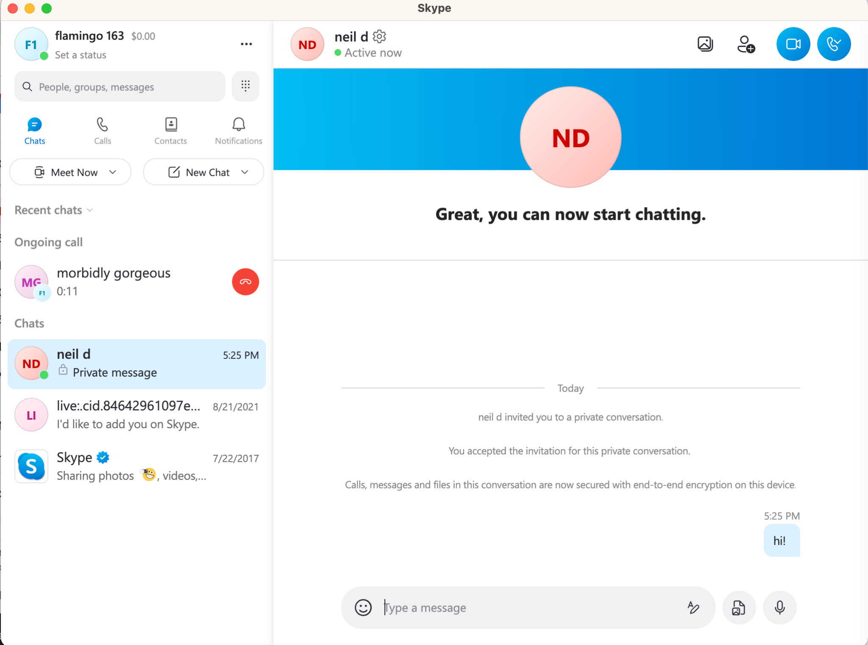

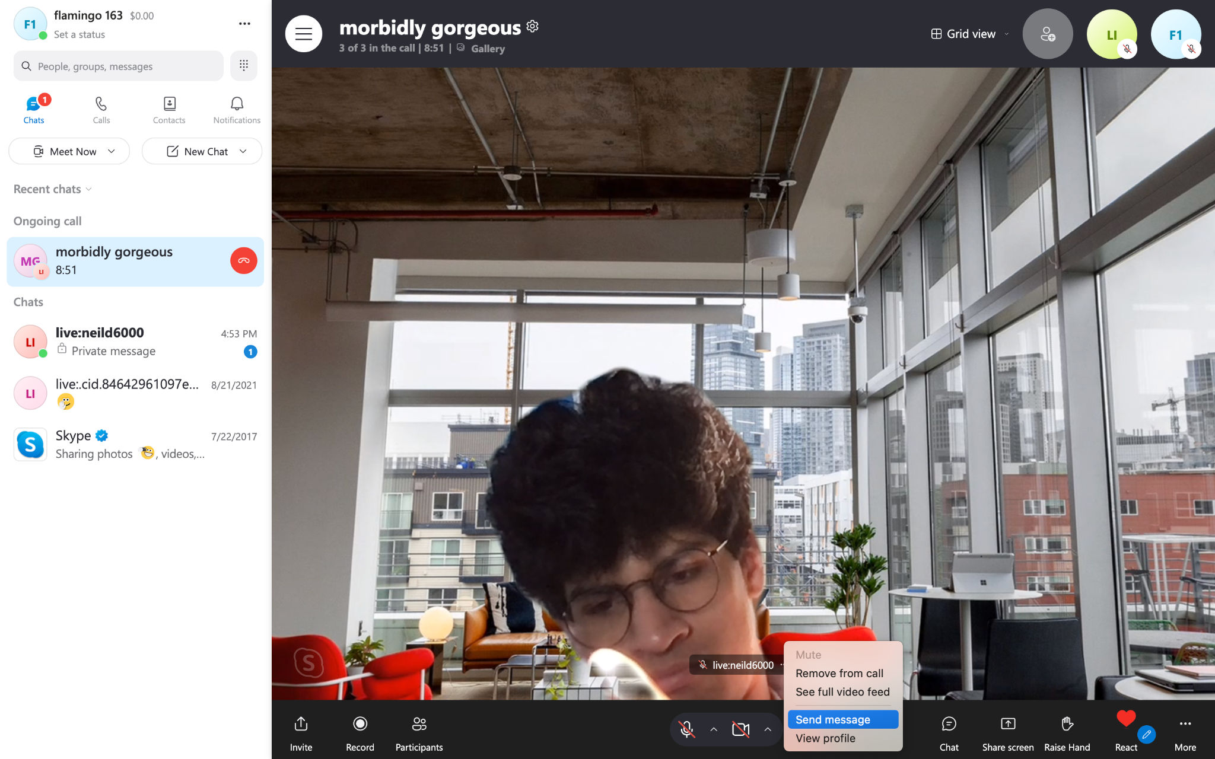

*Figure 18: Skype’s Chat Interface*

**Microsoft Teams BlueJeans**

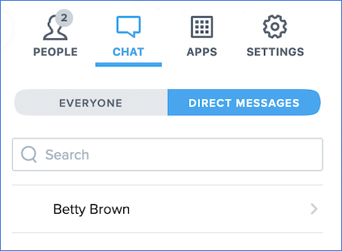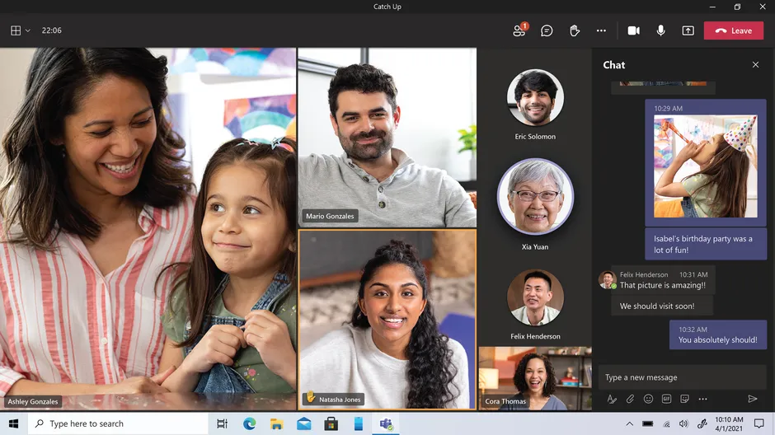

*Figure 20: BlueJeans’ Chat Interface*

*Figure 19: Microsoft Teams’ Chat Interface*

**Redesign**

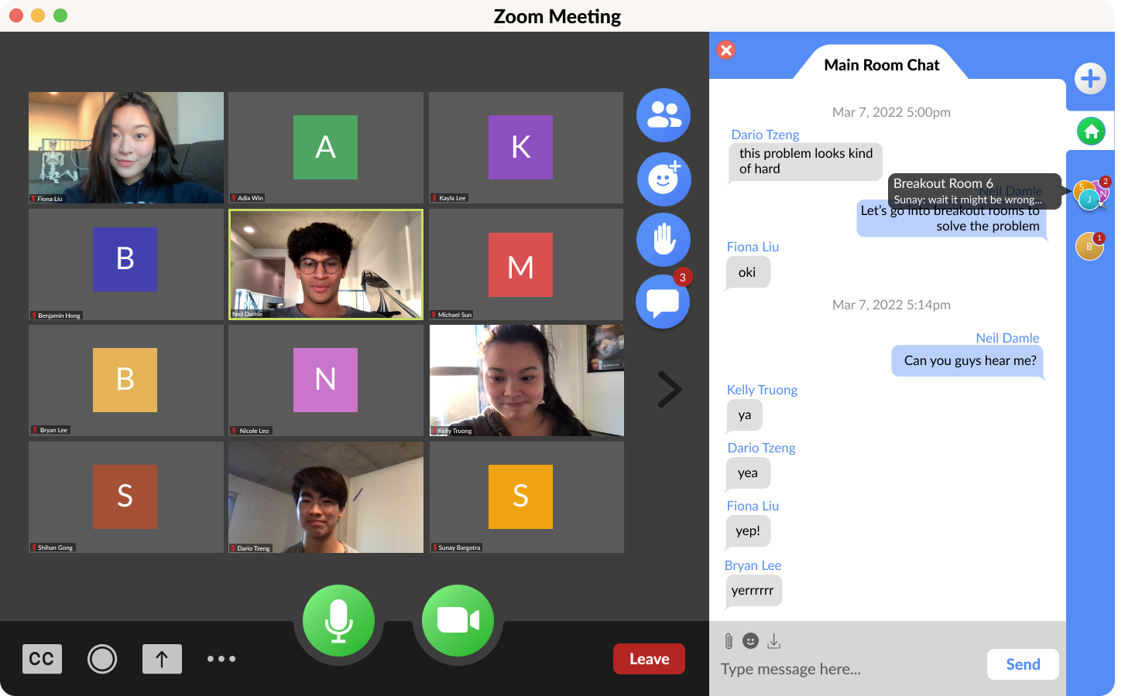

*Figure 21: Redesign’s Chat Interface*

**Design Space**

Compactness vs. Interchangeability

Compactness is how condensed the chat feature is, and how much space it leaves for the video interface. Interchangeability is how easy it is to navigate between different conversations.

Zoom: Zoom is very compact as it displays everything you need on one screen. The chat, participants, direct messages, and class chat, are all viewable at once. However, Zoom is not very interchangeable as there is no differentiation between different functions. For example, the main chat and direct messages have no distinctions to separate them, and the messages can be lost very easily in a big class setting.

Google Meet: Google Meet is less interchangeable than Zoom because there is no way to direct message participants in the meeting. This is why it is rated the lowest for interchangeability. Google Meet is very compact, however, because the main chat is viewable at the same time as the video calls.

Microsoft Teams: Similar to Google Meet, Microsoft Teams does not have a function for direct messaging participants while in a meeting. Similar to Zoom and Google Meet, the main chat is displayed alongside the videos. This is why it ranks amongst the highest for compactness.

Skype: Skype ranks in the middle of both compactness and interchangeability. It saves the private chats with participants in the meeting but cannot view them simultaneously. This makes it rank as high as the previous programs in terms of compactness.

Bluejeans: Bluejeans is not as compact as other programs such as Zoom and Google Meet as the chat takes up about 33% of the interface. However, it is very interchangeable as it has different windows for each direct message you send.

Redesign: Our redesign is very interchangeable as it clarifies the differences between the different chats. Each chat, direct messages, class chat, or breakout room chat have their own tab within the chat where the messages are saved. However, to show this bar takes more space the programs such as Zoom, Google Meet, or Microsoft Teams. Although, unlike Skype, you can still see the chat and video call simultaneously.

Ideal Design: The ideal design would provide interchangeability similar to our redesign, but still a lot of space like Zoom or Google Meet.

|  | Compactness | Interchangeability |
| --- | --- | --- |
| Zoom | 5 | 2 |
| Google Meet | 5 | 1 |
| Microsoft Teams | 5 | 1 |
| Skype | 3 | 3 |
| Bluejeans | 3 | 4 |
| Redesign | 4 | 5 |
| Ideal Design | 5 | 5 |

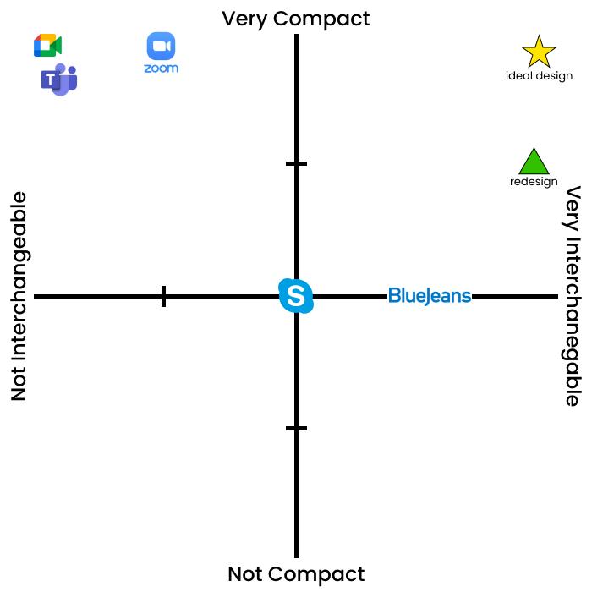

*Figure 22: design space of compactness vs. interchangeability*

Clarity vs. Aesthetic

Clarity is how straightforward the program is to use and if it has good signifiers. Aesthetic is how appealing the design of the interface is. It also accounts for how customizable the application is.

Zoom: Zoom ranks fairly clear because the chat icon is apparent upon loading into the meeting. However, the icon is lost amongst the other ten buttons that show up. On top of this, the direct message function’s **signifier** is very small therefore a lot of people are unaware of the ability to direct message. The aesthetic of zoom is also ranked very low because of the lack of customizability, as one interviewee noted the chat seemed “bare bones.”. Nothing about the interface design stands out as it is very simplistic.

Google Meet: Google Meet ranked amongst the lowest for clarity. This is because the chat button is tucked into the corner. It is not a part of the main buttons located in the center of the screen. There are also no **signifiers** to indicate to the user that the program cannot **afford** direct messages. When it comes to aesthetics Google Meet is very barebones. It does not allow for customization. It also shows no profile pictures which would be expected since google allows for icons in Gmail.

Microsoft Teams: Microsoft Teams displays the chat function grayed out. This time the button is located on the top right corner which may go against a lot of people’s **mental models**. However, Microsoft Teams allows for a lot of customization. This includes different styles and themes that the user has a lot of control over. This type of customization makes it rank so well as the user can make the interface their own.

Skype: Skype does a good job of making the interface clear as each of the buttons is fairly large. Skype also does a good job of incorporating colors into their interface as the buttons are the company’s staple blue.

Bluejeans: Bluejeans has a very clear interface as each of the buttons are laid out in a way that makes it easy to find. There are also different colors for when the button is active. Bluejeans is not very aesthetically pleasing as it offers no customization to the user.

Redesign: Our redesign makes it very clear to the user by having large buttons. We also included profile pictures and colors to make the aesthetic of the program very appealing.

Ideal Design: The ideal design would be something that makes it very clear to the user what the interface does at first glance. It would also allow the user to completely customize the chat to their liking, offering a multitude of themes for the user to get started.

|  | Clarity | Aesthetic |
| --- | --- | --- |
| Zoom | 3 | 2 |
| Google Meet | 2 | 2 |
| Microsoft Teams | 2 | 5 |
| Skype | 3 | 3 |
| Bluejeans | 5 | 3 |
| Redesign | 5 | 4.5 |
| Ideal Design | 5 | 5 |

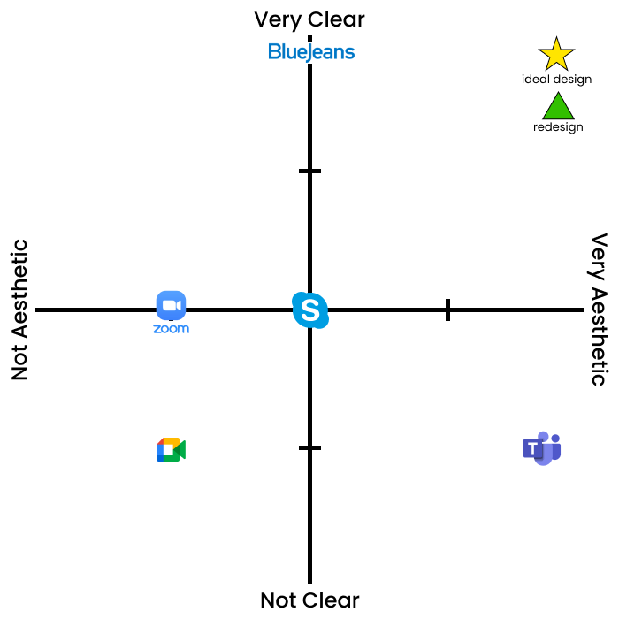

*Figure 23: design space of clarity vs. aesthetics*

**Redesign**

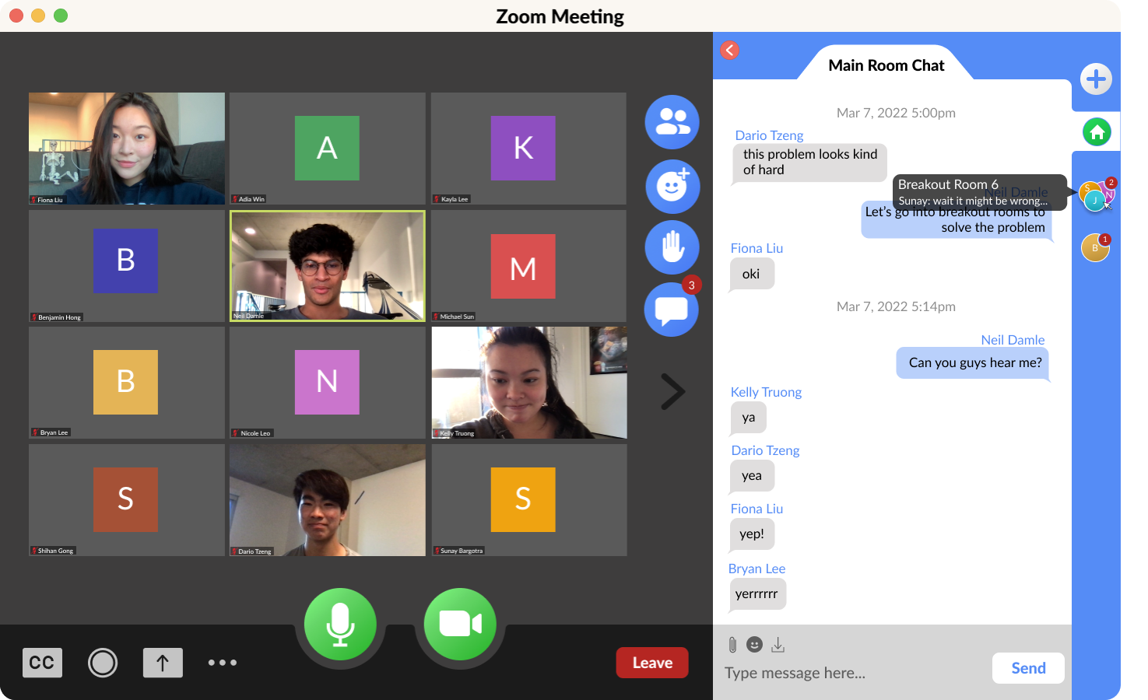

*Figure 24: Zoom Chat Redesign*

**\****See Redesign Prototype Section for more in-depth prototyping.*

We made all of the buttons more defined in general, but our redesign mainly features more defined chat vessels, with one for the main meeting, additional breakout rooms that the user was added into, as well as any user-created direct message chats or group chats. To preview the chat, one simply hovers over that chat’s icon.

Additional changes were made to message typing as well, such as replacing the “Attach File” and “Download Transcript” buttons and also adding a formal “Send” button.

**Justification**

**Chat Placement**

To combat the issue of poor **mapping** causing disruption by the pop-up chat window, we decided that no matter if the user was maximized in full screen or in a normal window, the chat would expand to the side by default. However, users will also have the option to dock the chat off into a separate window if that’s their preference by hovering over the split between the meeting and the chat.

**Messaging Interchangeability**

The original chat had low **discoverability** in where to alternate between sending a message to “Everyone” versus sending a “Direct Message,” which led to **description-similarity** and **mode-error slips** and **memory-lapse mistakes**, as users a) couldn’t find where to send a direct message, b) forgot to change it back to “Everyone” after direct messaging, and c) had trouble discerning which messages were direct messages, as they often got lost in the chat stream. We determined that it was best to break up the chat stream into individual chats instead of a single continuous one. This could be considered a **constraint**, as the elimination of the option to send a direct message in the same place as the main chat prohibits the user from even mixing it up that way.

Although we considered separating sections into email-style inboxes, our interviewees did like the original chat’s simplicity, so we compromised by incorporating different chats, but the ability to preview the chat by hovering over the chat icons, inspired by Discord.

**Searching for Participants**

The original chat interface included a search function; however, it was unclear and blended into the usual “Send a chat to…” title. We clarified this, so users know who they’re sending messages to.

**Breakout Rooms**

It was mentioned by an interviewee that in a Breakout Room, it was difficult to distinguish if the send “To: Everyone” was to everyone in the meeting or everyone in the breakout room, which indicated the lack of clarity in signifiers, as well as a preface to more **mode-error slips** as that function is used identically to control recipients in the main chat room as well. Because of this, we generated a new chat for each breakout room, allowing users to feel secure in who they’re sending the messages to from the large title of “Breakout Room _”, as well as allowing users to revisit breakout room chats to talk to their group members in the event of any miscommunication.

**Unclear Functions**

The three buttons for sending a message were a piece of paper, an emoji, and an ellipses who’s only drop down was to “Save Transcript.” This wasn’t really clear to our users, particularly because of the lack of **cultural constancy**, so we swapped the **signifiers** out for a paperclip for “Attach File”, and a download for “Save Transcript”. The addition of the “Send” button came with a user who’s enter key was malfunctioning, which the original chat interface lacked alternatives for.

**Trade-offs**

Many of the programs **trade-off** clear **signifiers** for more space. They prioritize the ability to have a lot on the screen by making the buttons smaller. However, this can lead to a bigger gap between the **gulf of execution** and **gulf of evaluation**. Having a lot of space for viewing meetings is beneficial; however, many of our participants have stated **errors** because of misclicks or due to the lack of clear **feedback**. For example, the Zoom direct message only states in small text “(Direct Message).” This leads users to double and triple check if they are messaging someone, fearful of making a **slip**. This led to our redesign to include bigger buttons and separate panels for different chats. This may have used more space; however, it allows users to see everything happening clearly. We implemented a minimize button for users who do not care about seeing the chat and instead wish to see the lecture in full screen.

**Section IV: Redesign Prototype**

**Prototype**

**Sample Run-Through**



*Figure 25: GIF of Zoom Chat Redesign Run-Through*

**Individual Frames**

**General Redesign**

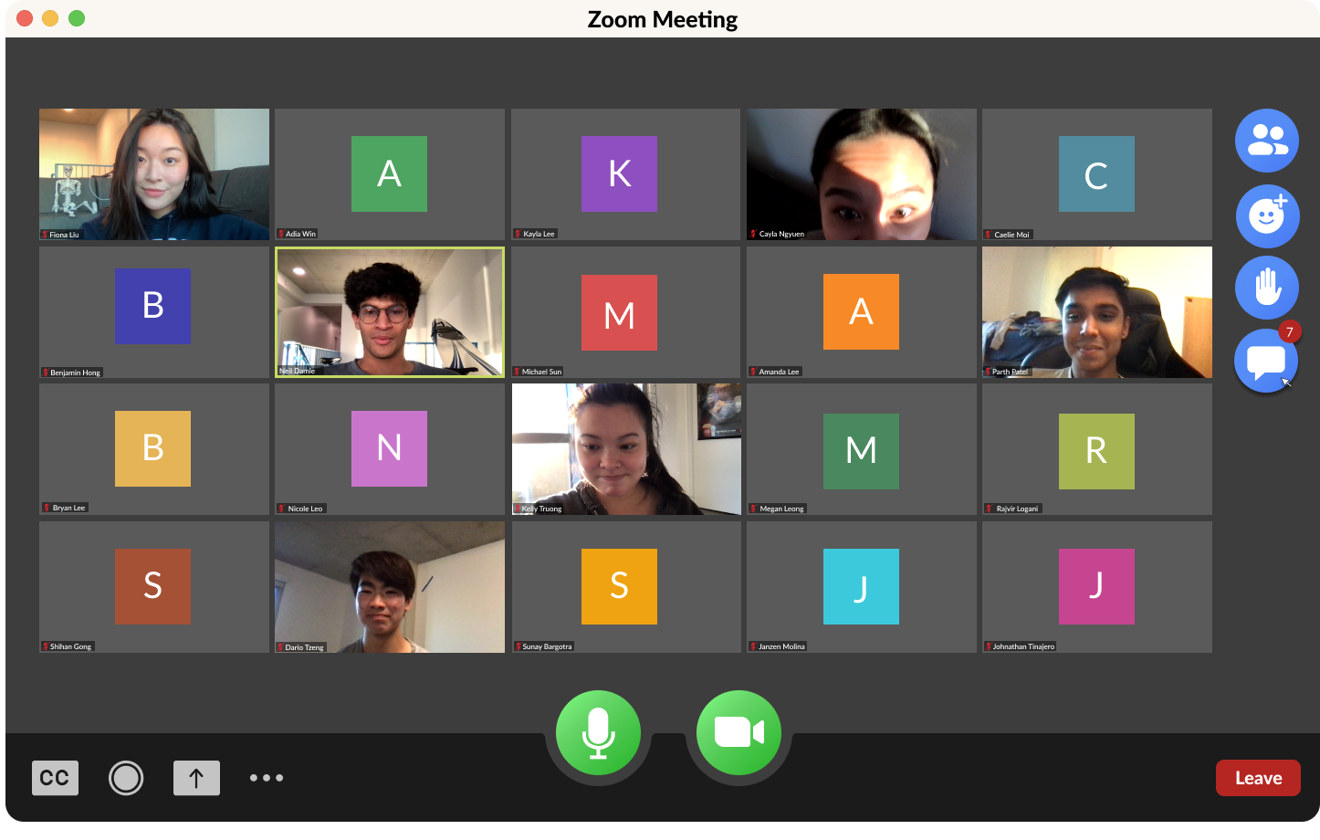

*Figure 26: General Meeting Interface*

Overall larger and colored buttons for more definition and clarity

**Introduction of a Side Chat Bar**



*Figure 27: Side Chat Bar*

Side Chat Bar for users’ main room chat, breakout room chat, and any additional created direct-messaging or group chats; To preview the chat, can hover over icon (Discord-inspired)

**Breakout Room Chats Revisitable**

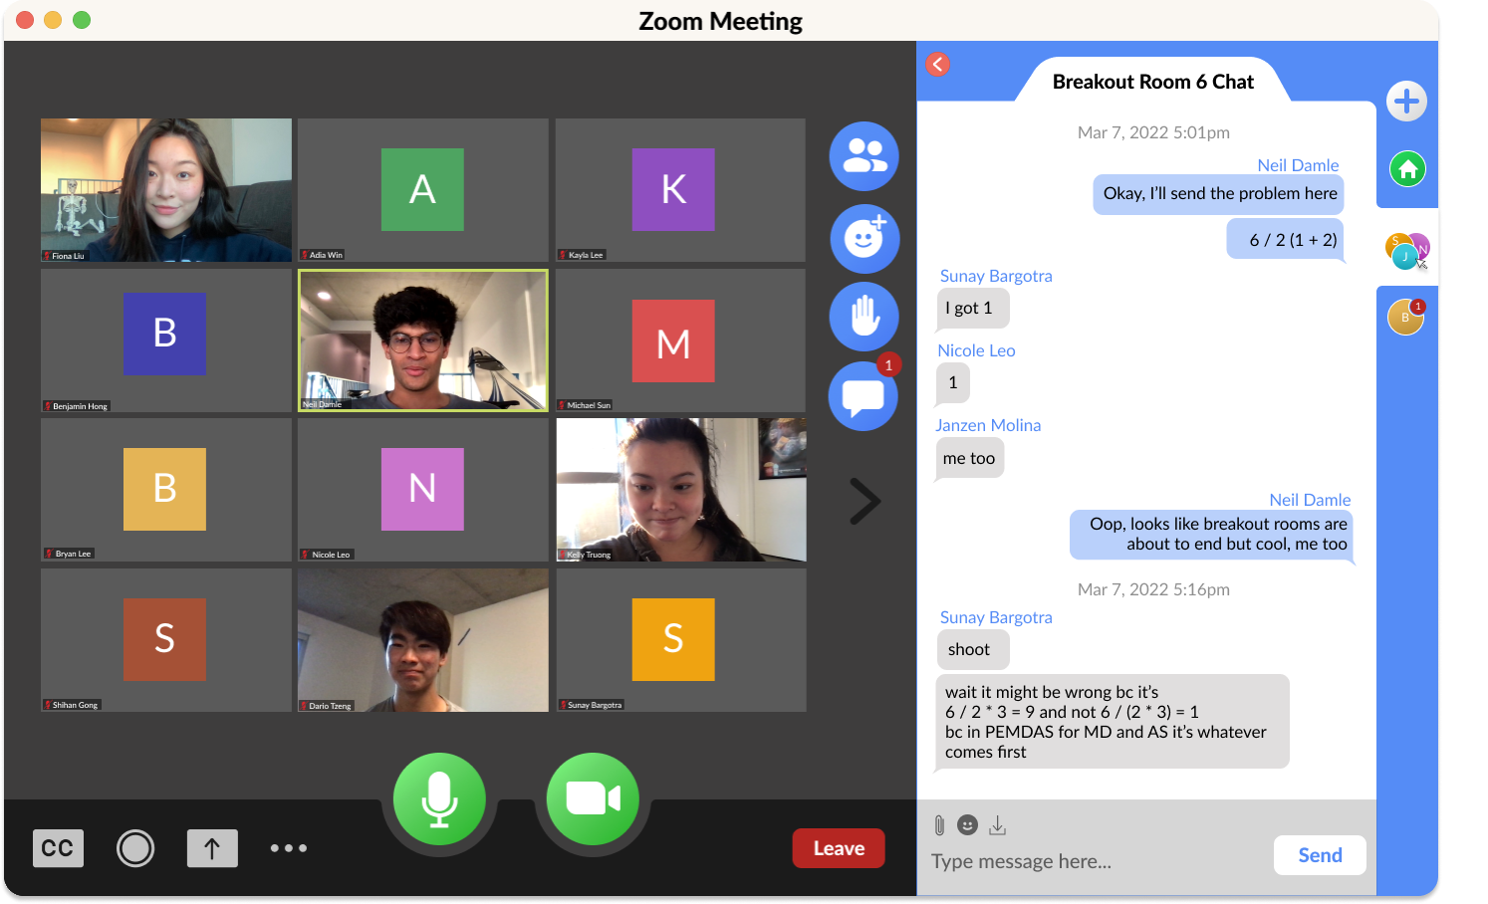

*Figure 28: Instance of user revisiting Breakout Room Chat*

The introduction of separated chat streams means users can now revisit Breakout Room Chats after the Breakout Room has ended; In the shown instance, it was helpful for members to reconsider their answers, promoting communication

**Signifier Change**



*Figure 29 & 30: Signifiers of Functions Changed*

Changed the signifiers of message functions to be more culturally constant; Paperclip for Attaching Files, Download for Save Transcript, and the addition of a Send button

**Starting New Chats**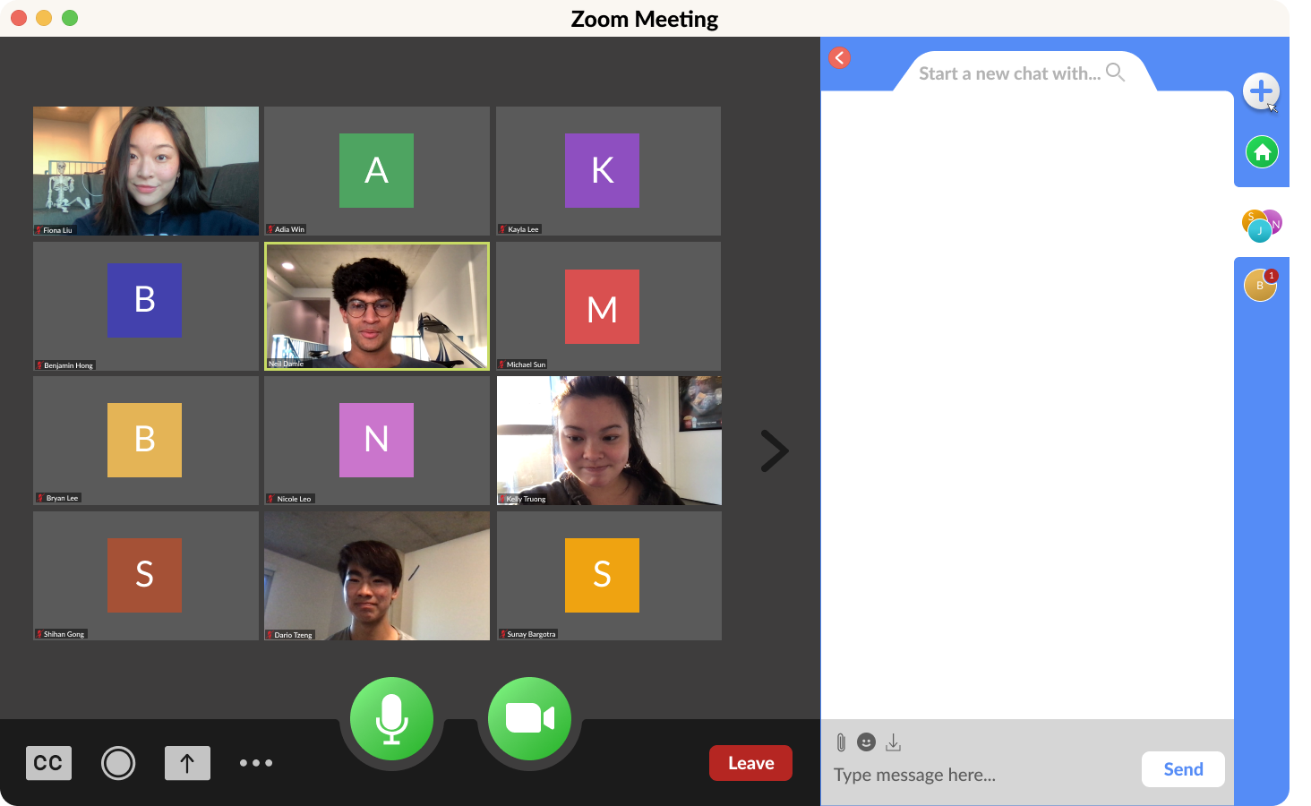

*Figure 31: Starting a New Chat*

To start a new chat, the user simply has to click the “+” button, and a blank chat will appear;

The “Start a new chat with…” and magnifying glass will signify users to select a recipient

**Searching for Recipients**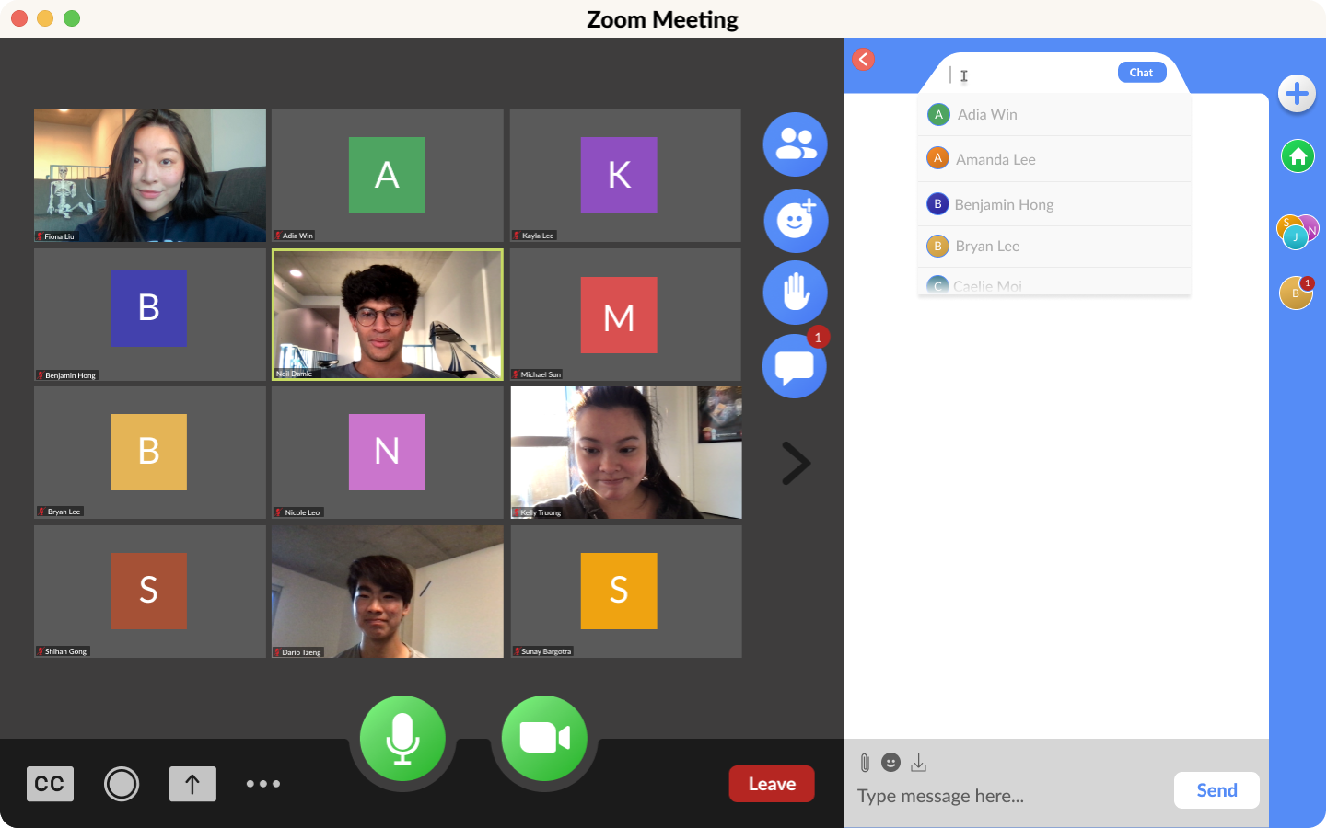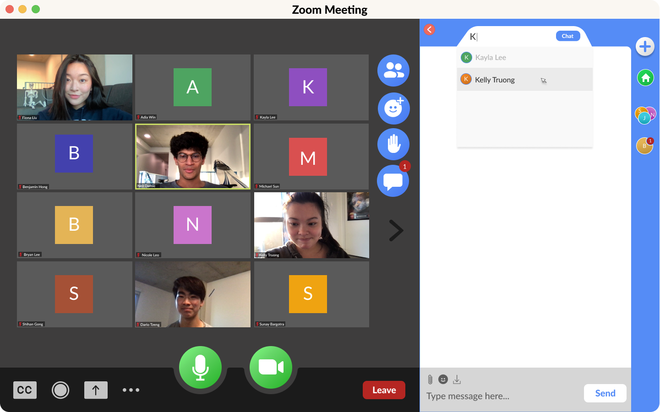

*Figures 32 & 33: Searching for a new recipient*

Once the user clicks on the search bar, a drop down menu will appear, where they can scroll through, or begin typing, where all participants whose names begin with that letter will appear

**Creating Group Chats**

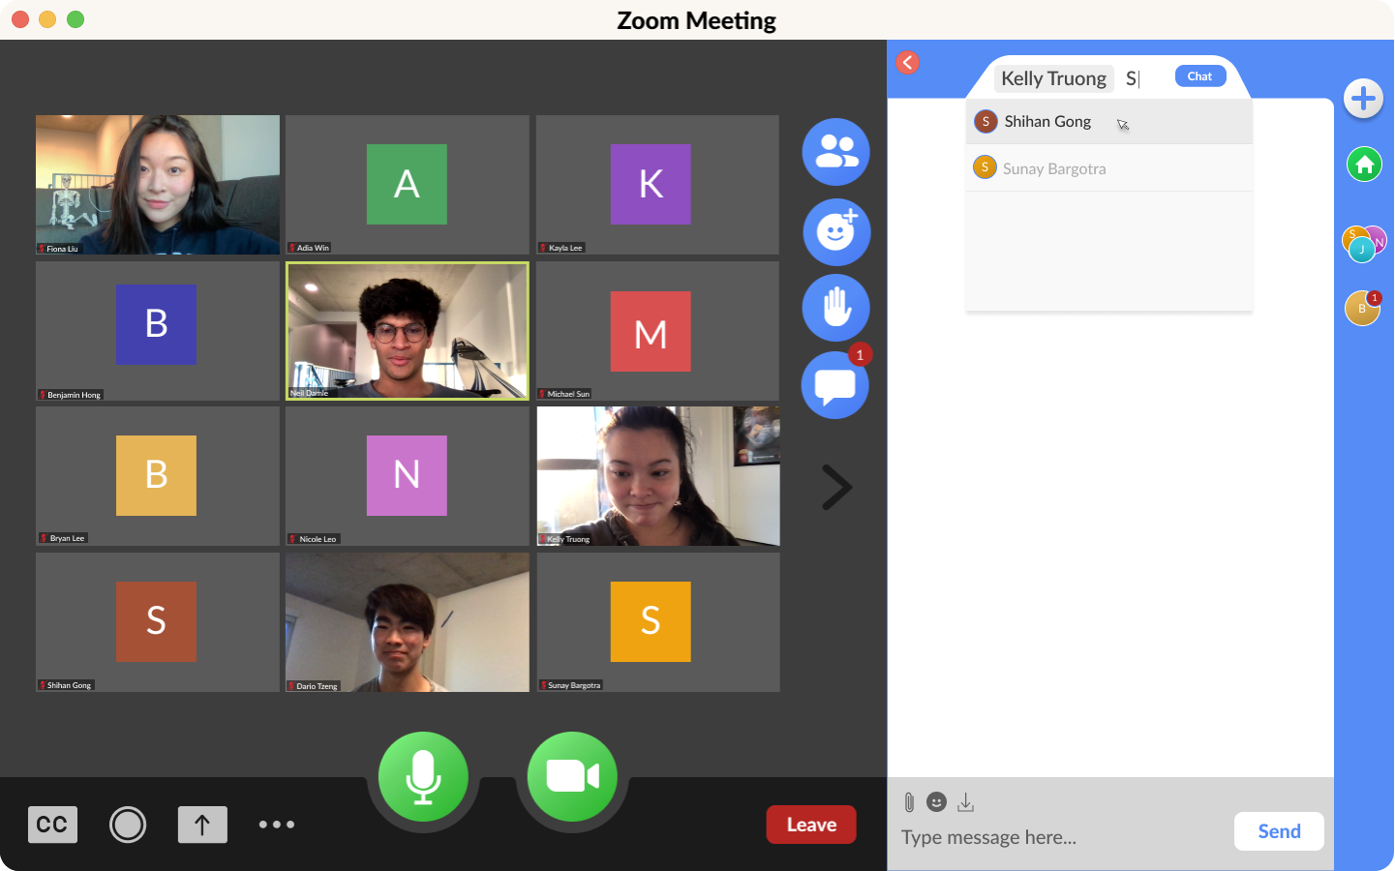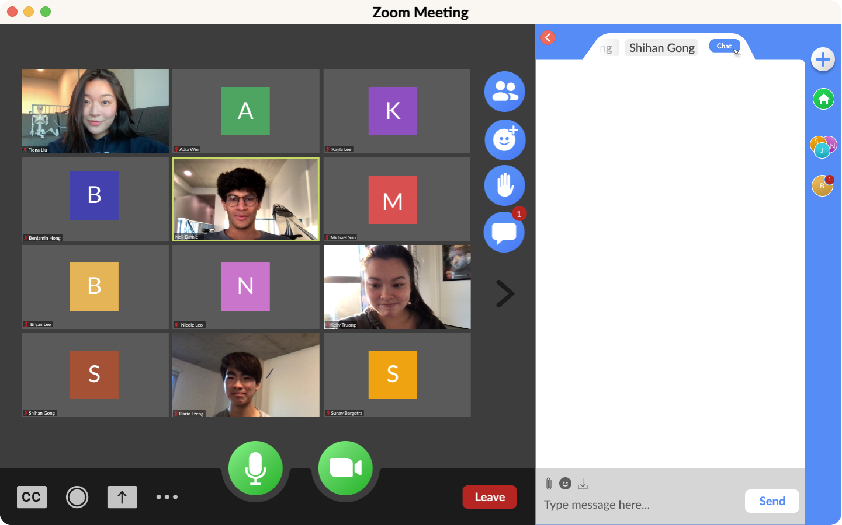

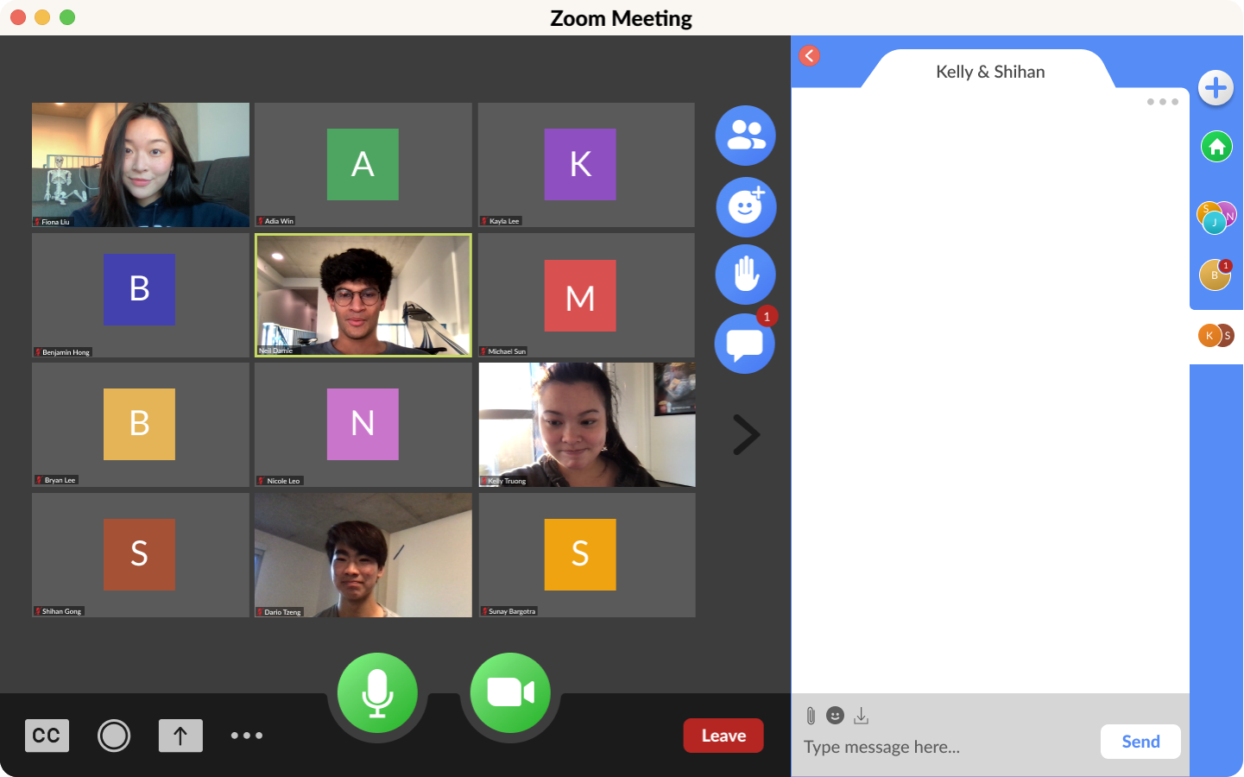

*Figures 34, 35 & 36: Creation of Group Chats*

One the new features we added was the ability to create group chats, after seeing how difficult it was to direct message every single person a user wanted to; Once the chat was made, the icon appears on the side

**Iteration**

According to Don Norman, there are two phases of the Double Diamond of Design: finding the right problem (discovering-divergent and defining-convergent) and finding the right solution (developing-divergent and delivering-convergent). In order to do this, designers follow a cycle for human-centered design consisting of 1) observation, 2) idea generation (ideation), 3) prototyping, and 4) testing.

During the **divergent stage of finding the problem**, we **discovered** the issue through **observation**. We employed the **master-apprentice model** of interviewees demonstrating their use of Zoom communication features such as the microphone, video, chat, and reactionsto see the **applied ethnography** of the natural occurrences they encounter. As opposed to **marketing research** that intends to conduct large-scale observation in pursuit of mass buying, our **design research** focused on the niche of population that used Zoom, which was a target audience of students ranging from elementary level to college level, as well as industry professionals who use Zoom for meetings.

Our **convergent stage of** **definition and ideation** began by identifying our interview data from the first form, where we found some accidents regarding microphone and video inconsistency, an indifference for reactions, and the outline of some issues with chat, like the lack of **discoverability** of direct messaging. From there, we actually revisited the **divergent stage** and **observed** using a new form, this time highlighting chat features. Only then did we land on our final problem, which was chat confusion, and thus a consequent need for separation between messages.

After that, we began a **divergent stage of developing**, and began **prototyping**. There were a few components that we were keeping in mind: a) clarifying recipients and chats to minimize errors and b) though the chat is pretty well-used, Zoom’s primary function is a video telephony communication method, meaning that we wanted to preserve written communication while saving space. We made some low-fidelity wireframes (Figures 34 & 35), which involved a lot of back and forth critique that helped us identify unseen problems. We played around with **alternate designs** centered around tabs and email-style inboxes, but ultimately integrated all of our critiques for an interchangeable yet compact chat into a final design of a Discord-style interchangeability system (see Redesign Prototype Section).

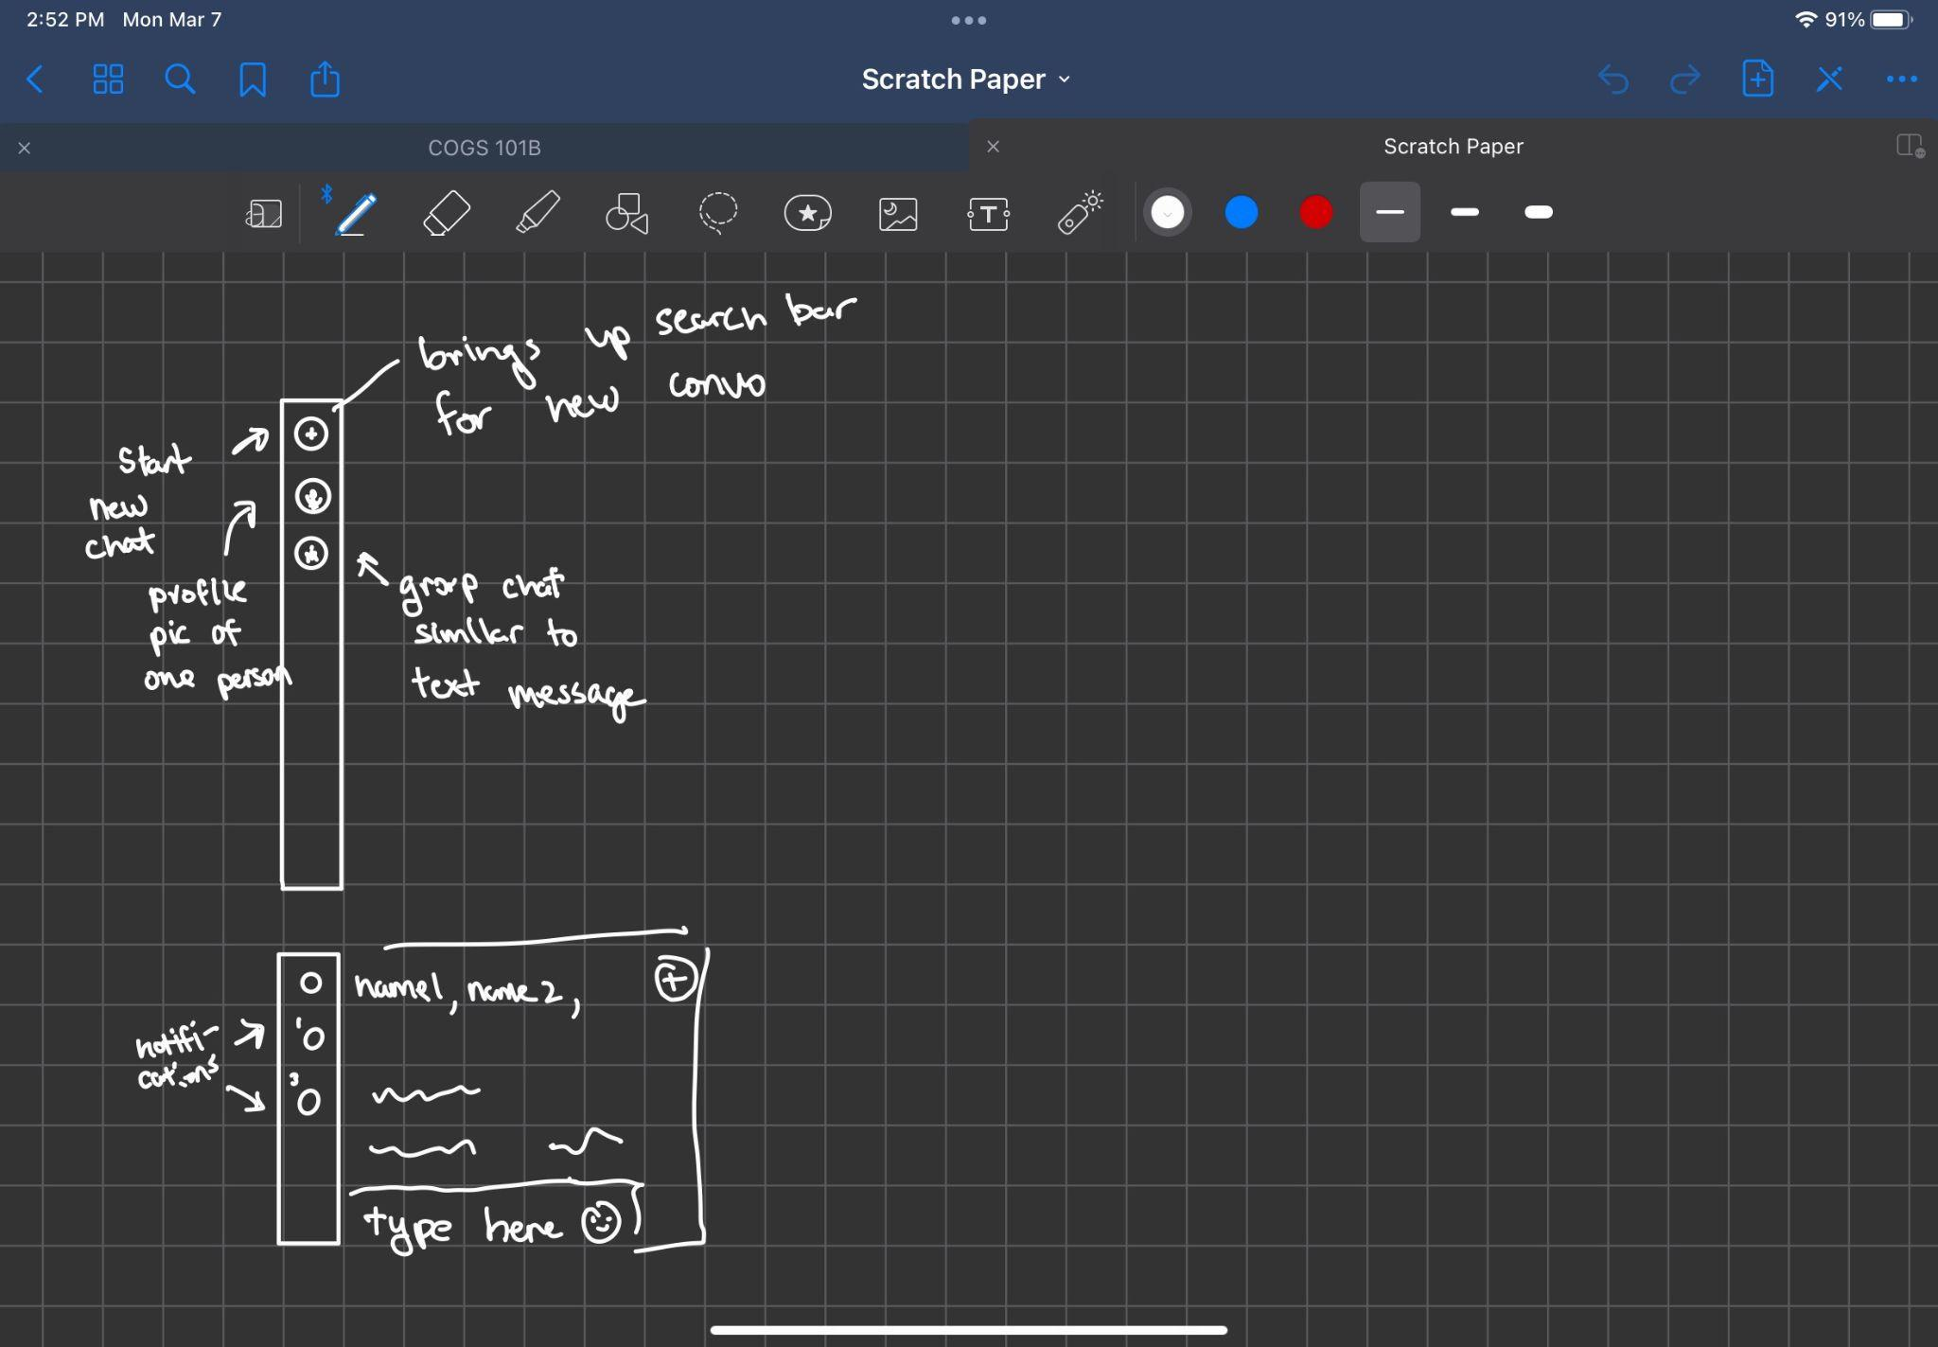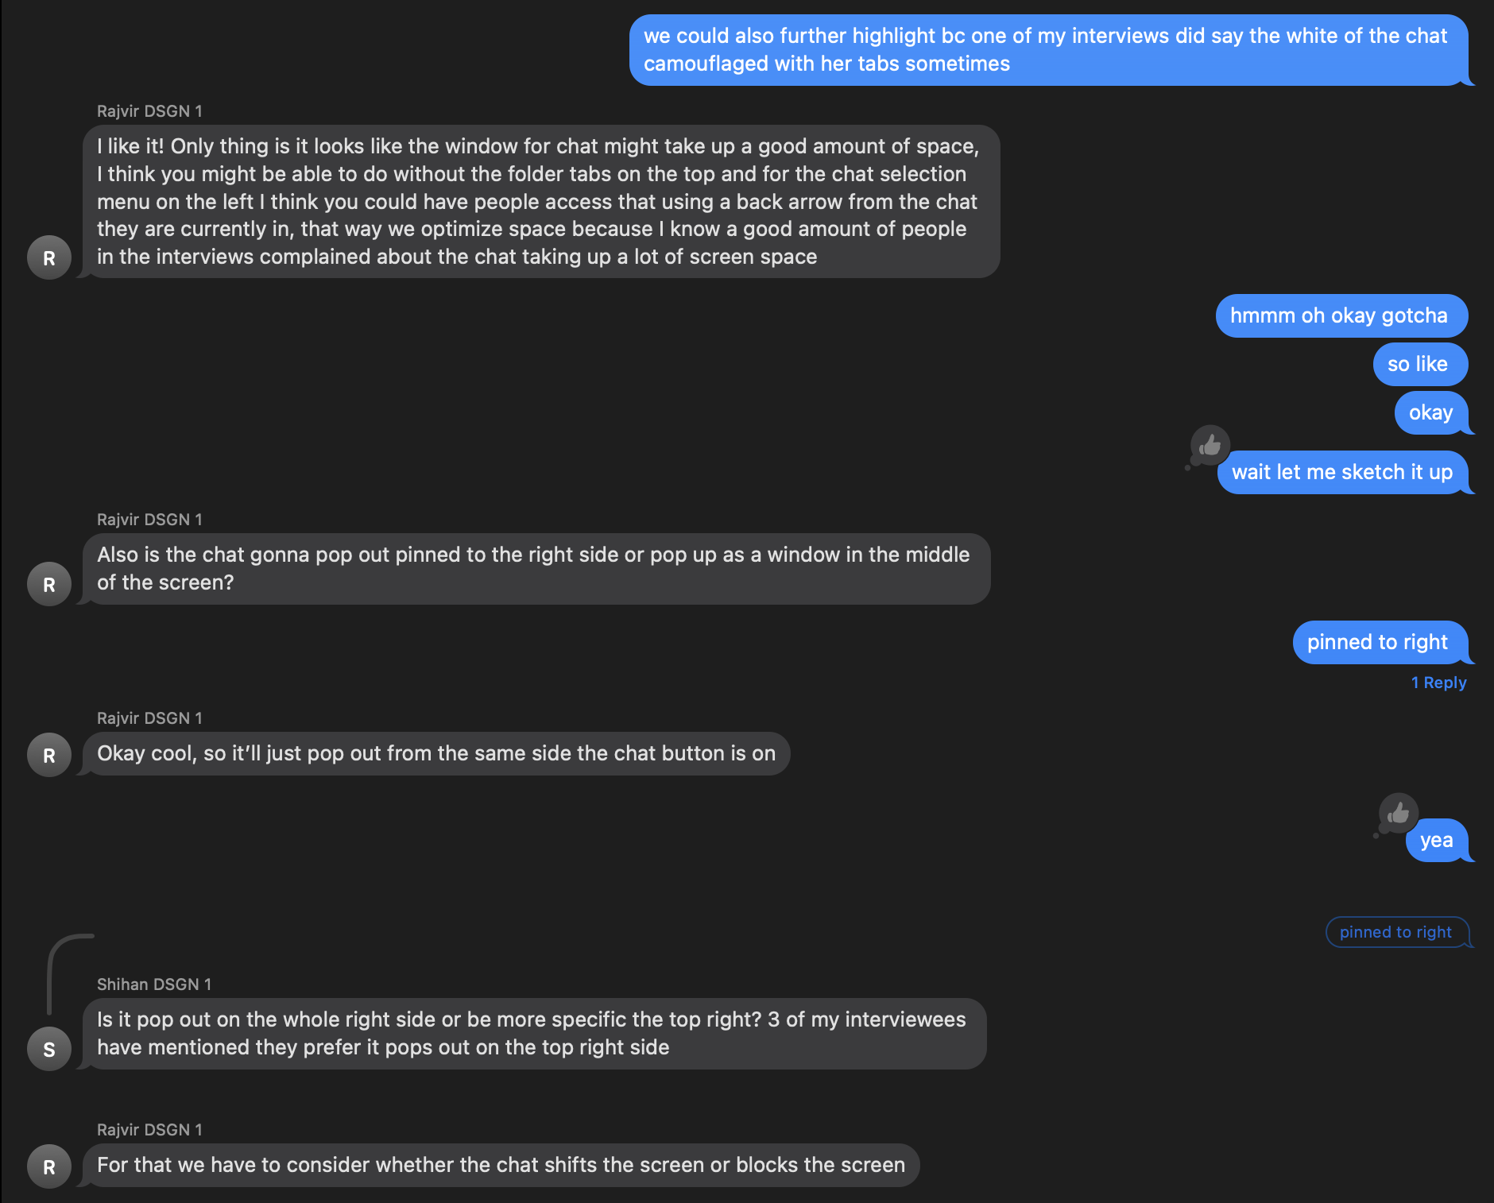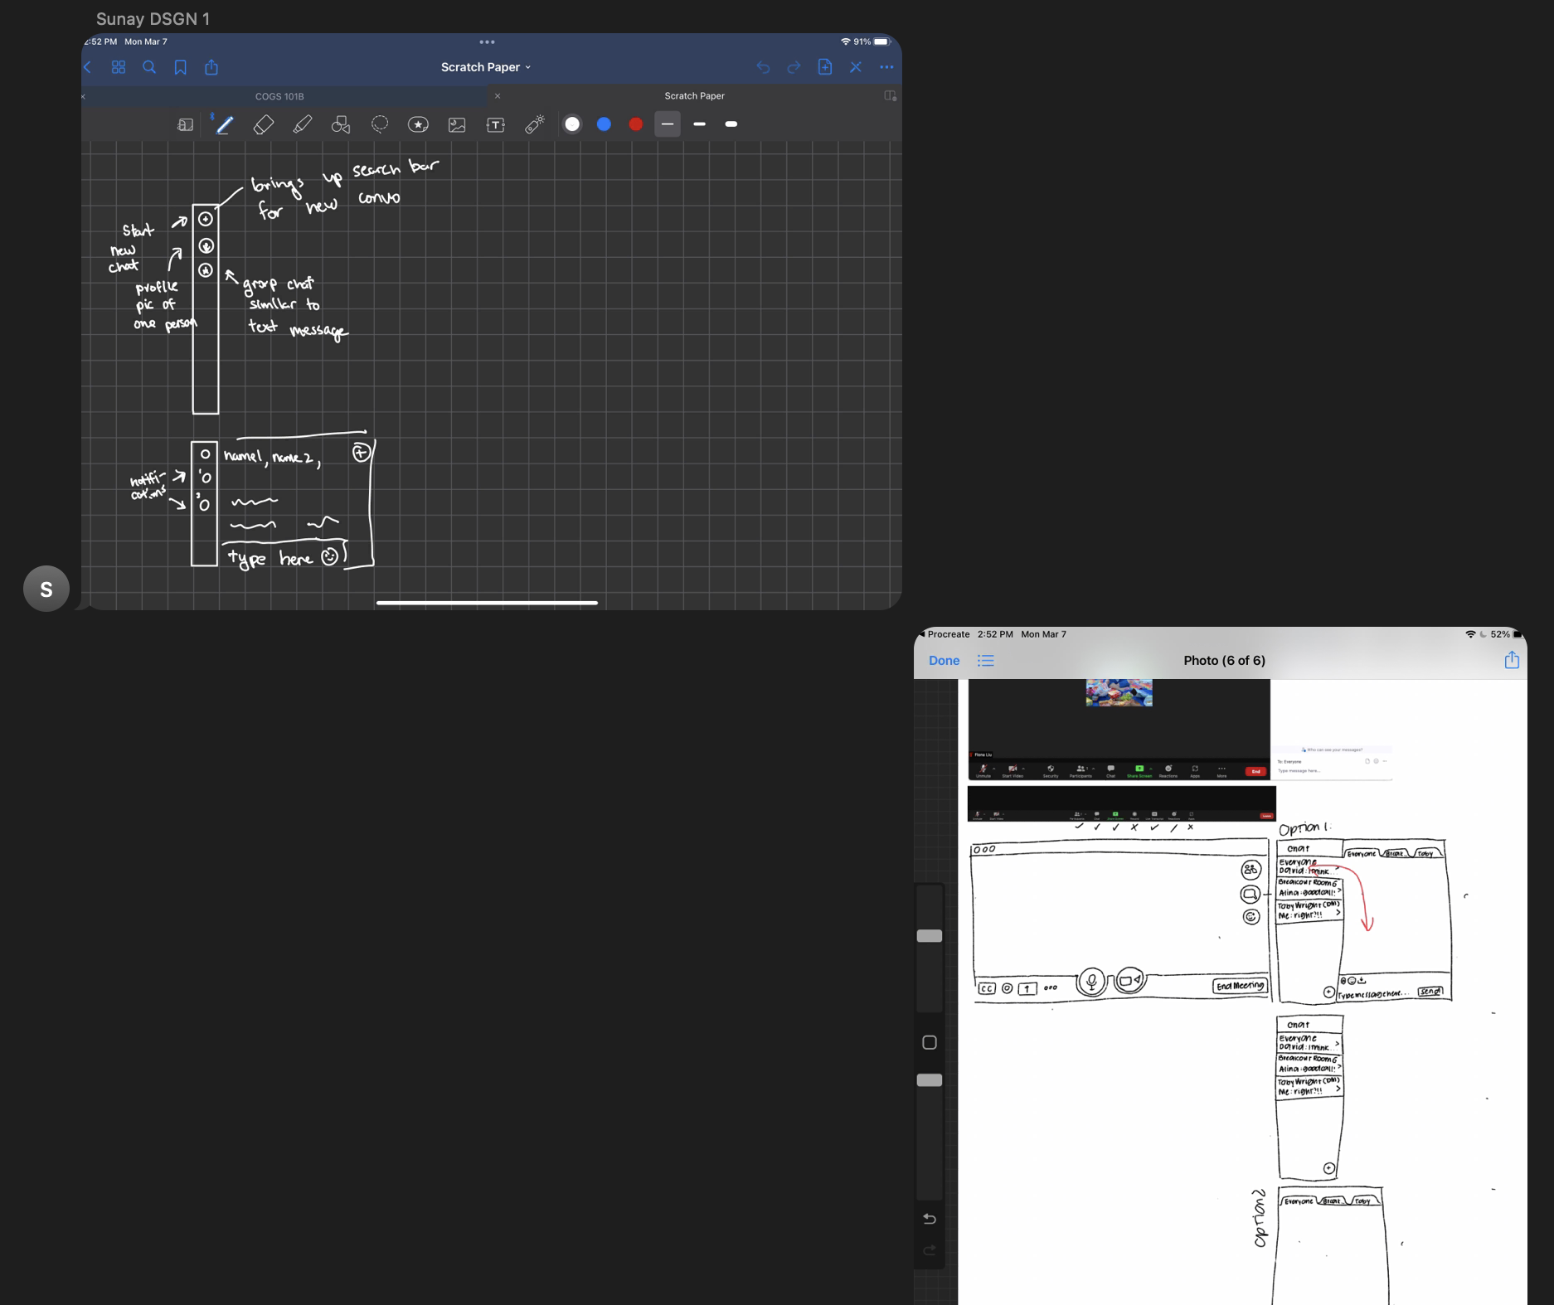

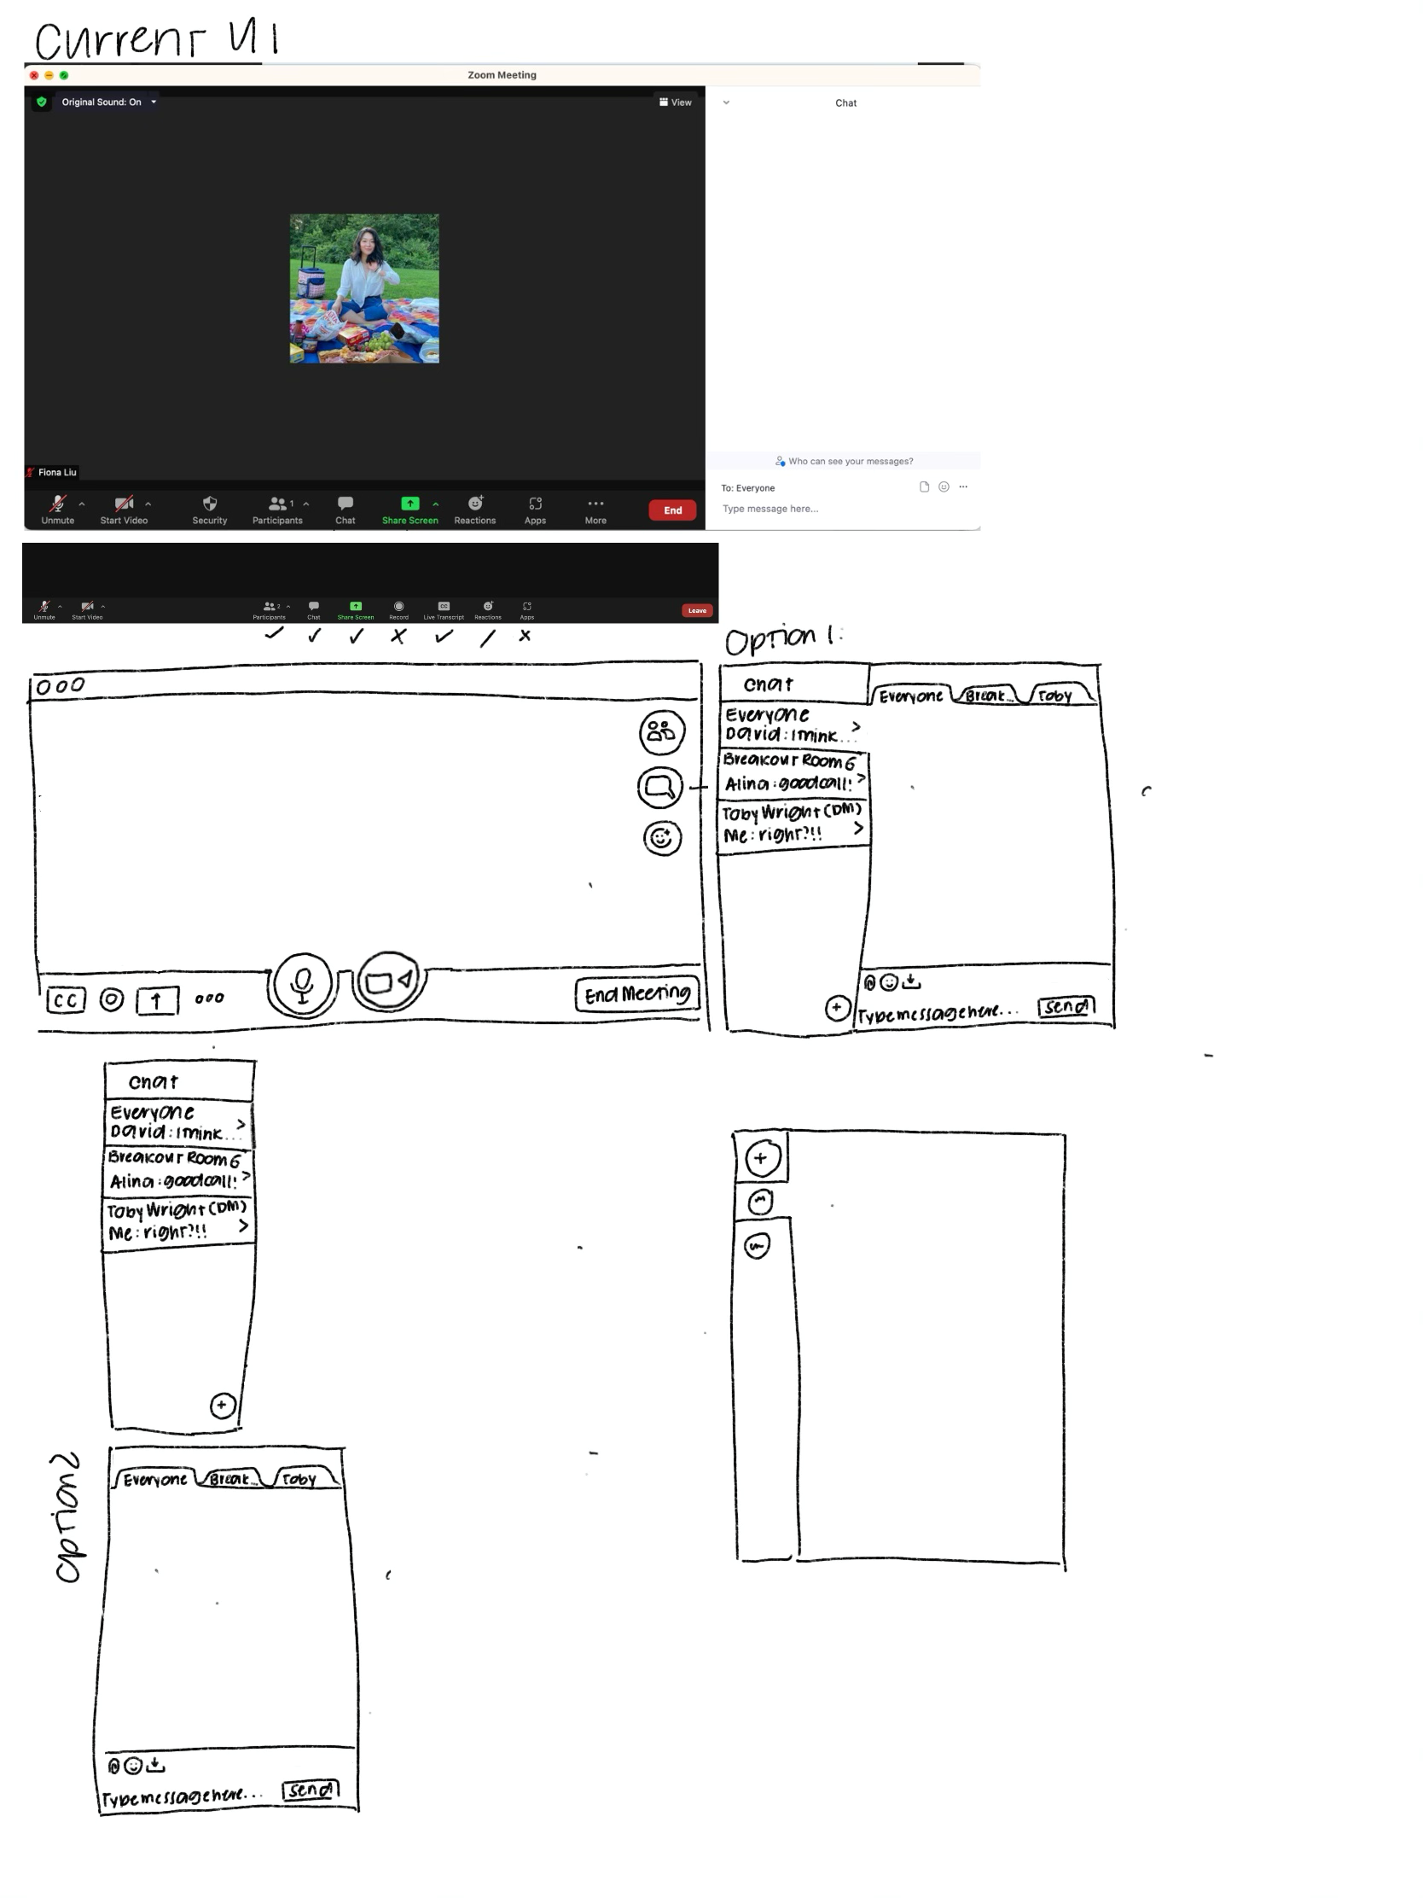

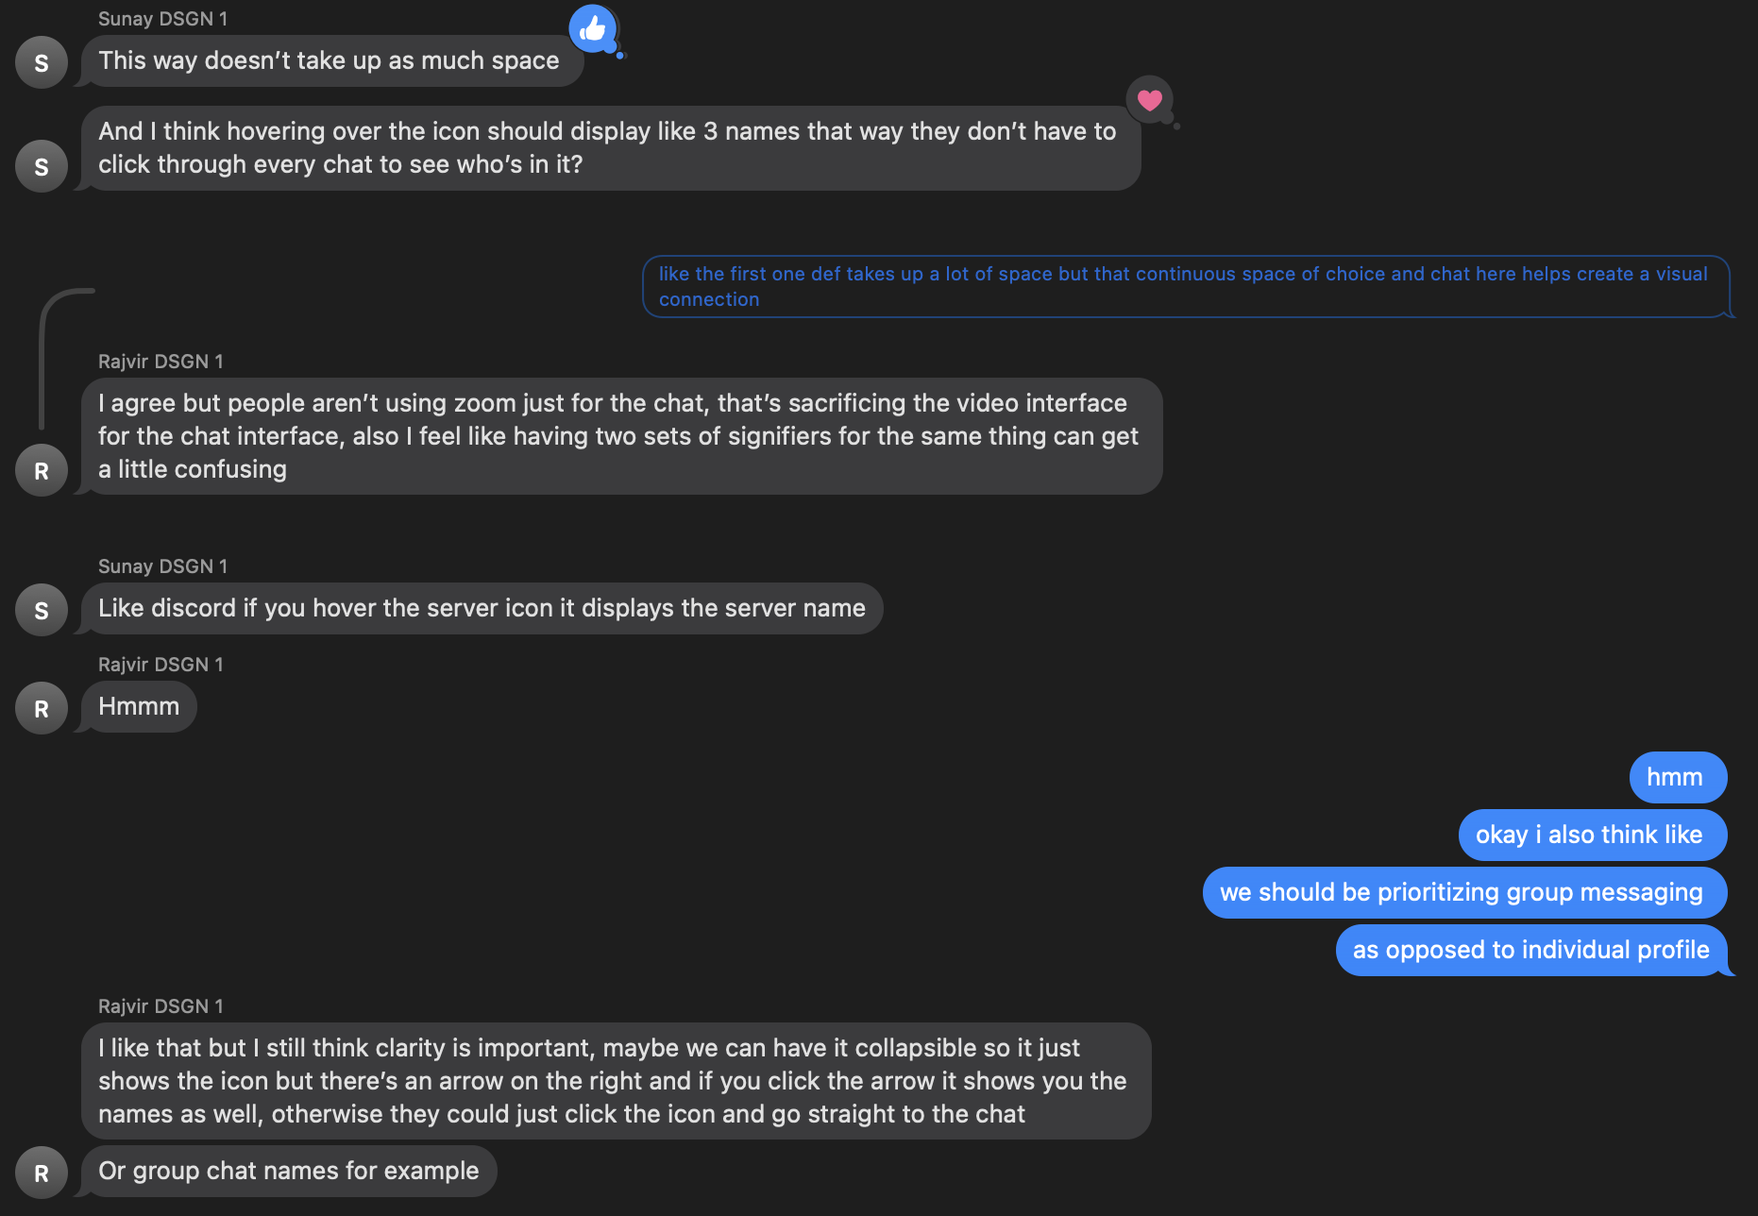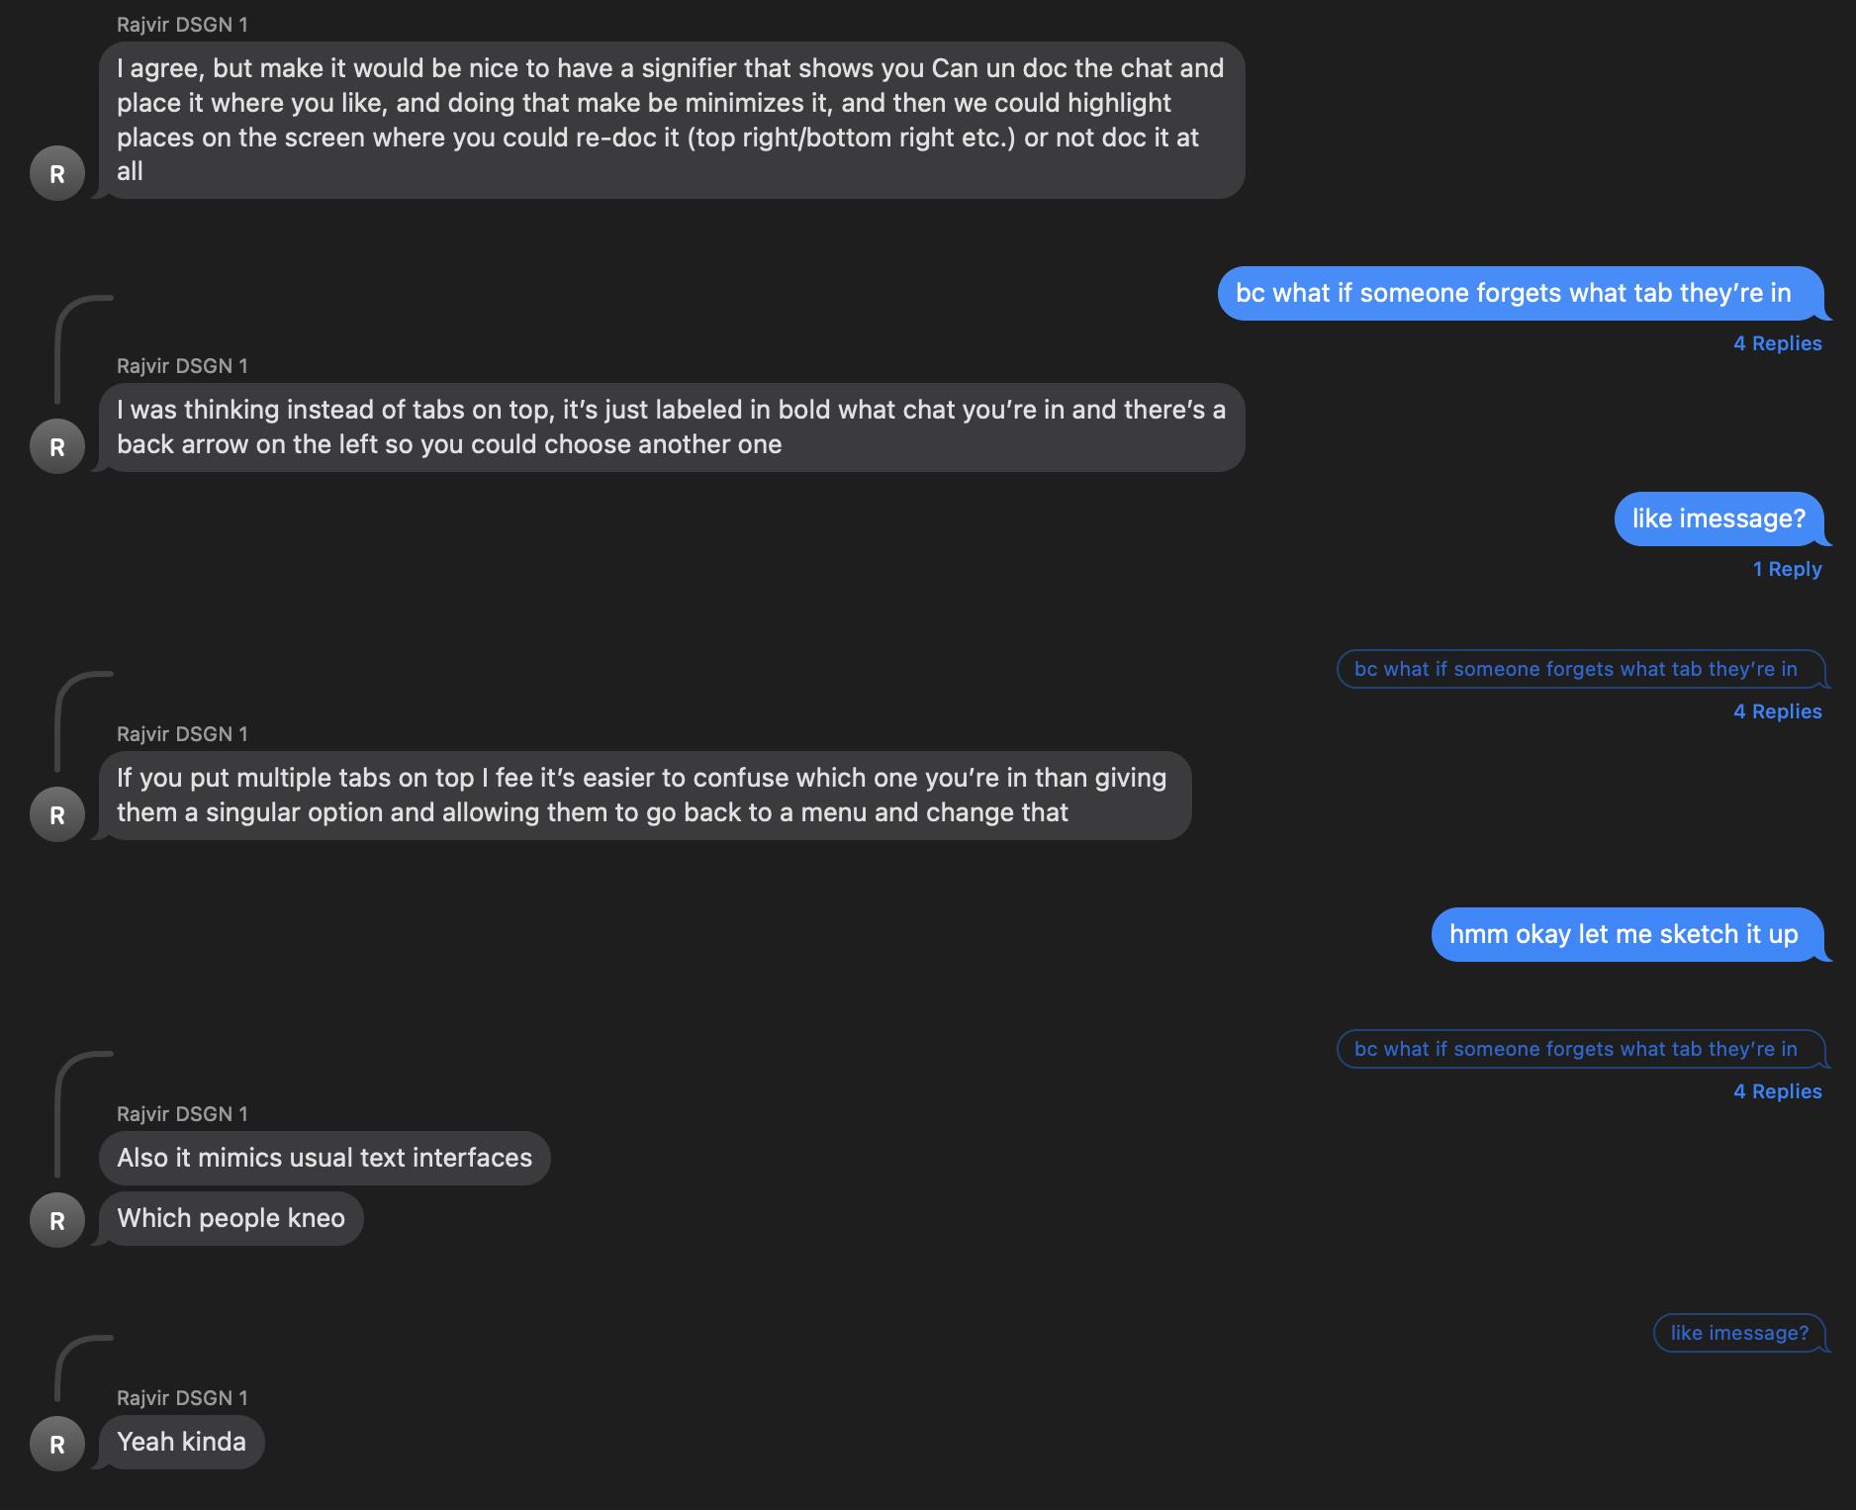

*Figures 41 & 42: Low-fidelity*

*wireframes*

*Figures 37, 38, 39, & 40: Critiques for our low-fidelity wireframes*

Since this was a class project with a limited project deadline, we didn’t have a great chance to complete the final **convergent stage of delivering** by **testing**, but we would hypothetically disseminate a working prototype to our initial interview group to identify any improvements or continued dissatisfactions.

**Section V: Conclusion**

From our data, there seem to be a slew of inconsistencies regarding some of the communication features, but for the sake of scope, we honed in on the most concentrated issues, which were found in the chat. Our hope for the redesigned chat is to solve the lack of clarity caused by the oversimplification by clearly defining differences in recipients and messages. Given more time on this project, we would send out our redesign to the original interviewee group to begin our **testing** stage, and then continue to iterate cyclically with a larger sample of feedback.